

**Department of Computer Applications**

**SOFTWARE ENGINEERING AND TESTING LAB**

**(USA20503J)**

**LAB MANUAL**

**for**

**BCA Degree Programme – 2020 Regulation**

**Academic Year (2022 – 2023) – Fifth Semester (Odd)**

**Prepared By Approved By**

**` HOD**

**INDEX**

|  |  |  |
| --- | --- | --- |
| **S.No** | **Name of the Program** | **Page No** |
| 1. | PROBLEM STATEMENT |  |
| 2. | SYSTEM REQUIREMENT SPECIFICATION |  |
| 3. | LIBRARY MANAGEMENT SYSTEM |  |
| 4. | AUTOMATED BANKING SYSTEM |  |
| 5. | AIRLINE RESERVATION SYSTEM |  |
| 6. | EMPLOYEE MANAGEMENT APPLICATION |  |
| 7. | HOSPITAL MANAGEMENT APPLICATION |  |
| 8. | DEVELOPMENT OF A BLOOD BANK MANAGEMENT SYSTEM |  |
| 9. | COVID PATIENTS’ MANAGEMENT SYSTEM |  |
| 10. | RESTAURANT TABLE MANAGEMENT SYSTEM |  |
| 11. | EVENT MANAGEMENT SYSTEM |  |
| 12. | CRIME REPORTING SYSTEM |  |
| 13. | BOOK RESALE APPLICATION |  |
| 14. | TOURS AND TRAVELS MANAGEMENT SYSTEM |  |
| 15. | APPLYING DATA MINING IN CYBER CRIME |  |

**Ex No: 1 PROBLEM STATEMENT**

AIM:To prepare a PROBLEM STATEMENT for any project.

## REQUIREMENTS:

##### Hardware Interfaces

* Pentium(R) 4 CPU 2.26 GHz, 128 MBRAM
* Screen resolution of at least 800 x 600 required for proper and complete viewingof screens. Higher resolution would not be aproblem.
* CD ROMDriver

##### Software Interfaces

* Any Windows-based operating system
* WordPad or MicrosoftWord

## THEORY:

The problem statement is the initial starting point for a project. It is basically a one to three page statement that everyone on the project agrees with that describes what will be done at a high level. The problem statement is intended for a broad audience and should be written in non- technical terms. It helps the non-technical and technical personnel communicate by providing a description of a problem. It doesn't describe the solution to the problem.

The input to requirement engineering is the problem statement prepared by customer.

It may give an overview of the existing system along with broad expectations from the new system.

The first phase of requirements engineering begins with requirements elicitation i.e. gatheringof information about requirements. Here, requirements are identified with the help of customer and existing system processes. So from here begins the preparation of problemstatement.

So, basically a problem statement describes **what** needs to be done without describing **how**.

**Conclusion:** The problem statement was written successfully by following the steps described above.

**Ex No: 2 SYSTEM REQUIREMENT SPECIFICATION**

AIM: Understanding an SRS.

##### REQUIREMENTS:

**Hardware Requirements:**

* PC with 300 megahertz or higher processor clock speed recommended; 233 MHz minimumrequired.
* 128 megabytes (MB) of RAM or higher recommended (64 MB minimumsupported)
* 1.5 gigabytes (GB) of available hard disk space
* CD ROM or DVDDrive
* Keyboard and Mouse(compatible pointingdevice).

##### Software Requirements:

* Rational Rose, Windows XP,

##### THEORY:

An SRS is basically an organization's understanding (in writing) of a customer or potential client's system requirements and dependencies at a particular point in time (usually) prior to any actual design or development work. It's a two-way insurance policy that assures that both the client and the organization understand the other's requirements from that perspective at a given point in time.

The SRS document itself states in precise and explicit language those functions and capabilities a software system (i.e., a software application, an e-commerce web site, and so on) must provide, as well as states any required constraints by which the system must abide. The SRS also functions as a blueprint for completing a project with as little cost growth as possible. The SRS is often referred to as the "parent" document because all subsequent project management documents, such as design specifications, statements of work, software architecture specifications, testing and validation plans, and documentation plans, are related toit.

It's important to note that an SRS contains functional and nonfunctional requirements only; it doesn't offer design suggestions, possible solutions to technology or business issues, or any other information other than what the development team understands the customer's system requirements to be.

A well-designed, well-written SRS accomplishes four major goals:

* It provides feedback to the customer. An SRS is the customer's assurance that the development organization understands the issues or problems to be solved and the software behavior necessary to address those problems. Therefore, the SRS should be written in natural language (versus a formal language, explained later in this article),in an unambiguous manner that may also include charts, tables, data flow diagrams, decision tables, and soon.
* It decomposes the problem into component parts. The simple act of writing down software requirements in a well-designed format organizes information, places borders around the problem, solidifies ideas, and helps break down the problem into its component parts in an orderlyfashion.
* It serves as an input to the design specification. As mentioned previously, the SRSserves as the parent document to subsequent documents, such as the software design specification and statement of work. Therefore, the SRS must contain sufficient detail in the functional system requirements so that a design solution can bedevised.
* It serves as a product validation check. The SRS also serves as the parent document for testing and validation strategies that will be applied to the requirements forverification.

SRSs are typically developed during the first stages of "Requirements Development," which is the initial product development phase in which information is gathered about what requirements are needed--and not. This information-gathering stage can include onsite visits, questionnaires, surveys, interviews, and perhaps a return-on-investment (ROI) analysis or needs analysis of the customer or client's current business environment. The actual specification, then, is written after the requirements have been gathered and analyzed.

# SRS should address the following

The basic issues that the SRS shall address are the following:

* + - 1. **Functionality**. What is the software supposed todo?
      2. **External interfaces**. How does the software interact with people, the system‘s hardware, other hardware, and othersoftware?
      3. **Performance**. What is the speed, availability, response time, recovery time ofvarious software functions,etc.?
      4. **Attributes**. What are the portability, correctness, maintainability, security,etc. considerations?
      5. **Design constraints imposed on an implementation**. Are there any required standards in effect, implementation language, policies for database integrity, resource limits, operating environment(s)etc.?

# Characteristics of a good SRS

An SRS should be

1. Correct
2. Unambiguous
3. Complete
4. Consistent
5. Ranked for importance and/orstability
6. Verifiable
7. Modifiable
8. Traceable

**Correct** - This is like motherhood and apple pie. Of course you want the specification to be correct. No one writes a specification that they know is incorrect. We like to say - "Correct and Ever Correcting." The discipline is keeping the specification up to date when you find things that are not correct.

**Unambiguous -** An SRS is unambiguous if, and only if, every requirement stated therein has only one interpretation. Again, easier said than done. Spending time on this area prior to releasing the SRS can be a waste of time. But as you find ambiguities - fix them.

**Complete -** A simple judge of this is that is should be all that is needed by the software designers to create the software.

**Consistent -** The SRS should be consistent within itself and consistent to its reference documents. If you call an input "Start and Stop" in one place, don't call it "Start/Stop" in another.

**Ranked for Importance -** Very often a new system has requirements that are really marketing wish lists. Some may not be achievable. It is useful provide this information in the SRS.

**Verifiable -** Don't put in requirements like - "It should provide the user a fast response."Another of my favorites is - "The system should never crash." Instead, provide a quantitative requirement like: "Every key stroke should provide a user response within 100milliseconds."

**Modifiable -** Having the same requirement in more than one place may not be wrong - but tends to make the document not maintainable.

**Traceable -** Often, this is not important in a non-politicized environment. However, in most organizations, it is sometimes useful to connect the requirements in the SRS to a higherlevel document. Why do we need this requirement?

# A sample of basic SRS Outline

# Introduction

* 1. Purpose
  2. Document conventions
  3. Intended audience
  4. Additional information
  5. Contact information/SRS team members
  6. References

1. **Overall Description**
   1. Product perspective
   2. Product functions
   3. User classes and characteristics
   4. Operating environment
   5. User environment
   6. Design/implementation constraints
   7. Assumptions and dependencies
2. **External InterfaceRequirements**
   1. User interfaces
   2. Hardware interfaces
   3. Software interfaces
   4. Communication protocols and interfaces
3. **SystemFeatures**
   1. System feature A
      1. Description and priority
      2. Action/result
      3. Functional requirements
   2. System feature B
4. **Other Nonfunctional Requirements**
   1. Performance requirements
   2. Safety requirements
   3. Security requirements
   4. Software quality attributes
   5. Project documentation
   6. User documentation

##### Other Requirements

Appendix A: Terminology/Glossary/Definitions list Appendix B: To be determined

**Conclusion:** The SRS was made successfully by following the steps described above.

**Ex No: 3 LIBRARY MANAGEMENT SYSTEM**

* 1. **PROBLEM DEFINITION**

The library management system is software, which automates the job of a librarian.

* 1. The user can inquire about the availability of a book in which he can search by entering the author’s name or by entering the title of thebook.
  2. The user can borrow a book. He must provide the username and the card number, which is unique and confidential to each user. By confirming the authenticity of a user, the library management system provides information about the number of books already borrowed by the user and by referring to the database whether the user can borrow books or not. The library management system allows the user to enter the title and the author of the book and hence issues the book if it isavailable.
  3. By entering the user details and the book details the user can return the borrowedbook.

# SYSTEM REQUIREMENTSPECIFICATION

* 1. **INTRODUCTION**
     1. Purpose
        1. The purpose of this SRS is to describe the requirements involved in developing a Library managementsystem.
        2. The intended audience is any person, who wants to inquire, borrow and return thebooks.
     2. Scope
        1. The product is titled Library ManagementSystem.
        2. The product will perform the followingtasks
           1. Enquire about the availability of books.
           2. Borrow books ifavailable.
           3. Return the borrowed books.
     3. Definitions, Acronyms andAbbreviations
        1. DDBMS – Database ManagementSystem.
     4. References
        1. IEEE standard 830-1998 recommended practice for Software RequirementsSpecifications-Description.
     5. Overview
        1. The SRS contains an analysis of the requirements necessary to help easy design.
        2. The overall description provides interface requirements for the Library Management System, product perspective, hardware interfaces, software interfaces, communication interface, memory constraints, product functions, user characteristics and other constraints.
        3. Succeeding pages illustrate the characteristics of typical naïve users accessing the system along with legal and functional constraints enforced that affect Library Management System in anyfashion.

# THE OVERALL DESCRIPTION

* + 1. Product perspective
       1. Hardware interfaces
          1. Hard disk: The database connectivity requires a hardware configuration that is on-line. This makes it necessary to have a fast database system running on high rpm hard disk permitting complete data redundancy and back-up systems to support the primary goal ofreliability.
          2. The system must interface with the standard output devise, keyboard and mouse to interact with thissoftware.
       2. Software interfaces
          1. Back End: MS-Access 2007
          2. Front End: Microsoft Visual Basic 6.0
       3. Memory Constraints
          1. No specific constraints onmemory.
       4. Operations
          1. The software allows three modes of operations 2.2.1.4.1.1 Enquire about the availability and status ofbooks.

By extracting the username and password the software allows the user to borrow a maximum of threebooks.

By extracting the username and password the software allows the user to return the borrowedbooks.

* + 1. Product Functions
       - 1. Enquire about the availability and status ofbooks.
         2. Search the availability of book by entering the title of thebook.
         3. Search the availability of book by entering the author of thebook.
         4. The software validates the authentic user by extracting their username andpassword.
         5. After the validation of the user software allows the user to borrow a maximum of three books based on the number of books which wherealready borrowed.
         6. After the validation of the user software allows the user to returnthe books, which where borrowed.
    2. Usercharacteristics
       1. The intended users of this software need not have specific knowledge as to what is the internal operation of the system. Thus the end user is at a high level of abstraction that allows easier, faster operation and reduces the knowledge requirement of enduser
       2. The Product is absolutely user friendly, so the intended users can be the naïveusers.
       3. The product does not expect the user to possess any technical background. Any person who knows to use the mouse and the keyboard can successfully use thisproduct.
    3. Constraints
       1. The user has a unique username and password, there are no options to retrieve a password or username in case it is forgotten or lost hence the user is requited to remember or store the username andpassword.

# SPECIFICREQUIREMENTS

* + 1. Logical DatabaseRequirements
       1. The system should contain databases that include all necessary information for the product to function according to the requirements. These include relations such as user details and bookdetails.
       2. The user details refer to the information such as name, card number, no. of books borrowed, the title and the name of the author of the books that were borrowed.
       3. The book details refer to the information such as the title of the book, author availability status and the number of copies that isavailable.

# FRONT – ENDDESCRIPTION

The library management system is automated library system where the user can search for the book by either entering the details of the book or the author’s name. By entering the username and the password the software, by checking the number of books that are already borrowed enables us to borrow a maximum of three books. And by entering the username and password (card number), which is unique, the user can return the books.

# BACK – ENDDESCRIPTION

The library management system consists of two tables. One contains the student details such as the name, card number that is the password, title and the author of the three books, which could be borrowed. The book details consist of the title of the book, number of copies, author and the availabilitystatus.

# DATASTRUCTURES

* + 1. BOOKDETAILS

|  |  |  |
| --- | --- | --- |
| **FIELD NAME** | **TYPE** | **CONSTRAINTS** |
| REGISTER_NO | NUMBER | NOT NULL |
| BOOK_ID | NUMBER | NOT NULL |
| ISSUE_DATE | DATE/TIME |  |
| RETURN_DATE | DATE/TIME |  |
| BOOK_NAME | TEXT |  |

* + 1. STUDENTDETAILS

|  |  |  |
| --- | --- | --- |
| **FIELD NAME** | **TYPE** | **CONSTRAINTS** |
| REGISTER_NO | NUMBER | NOT NULL |
| FNAME | TEXT | NOT NULL |
| LNAME | TEXT |  |
| GENDER | TEXT |  |
| DEPT | TEXT |  |
| EMAIL | TEXT |  |
| PASSWORD | TEXT |  |
| NO_OF_BOOKS | NUMBER |  |

# DATA FLOWDIAGRAM

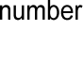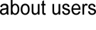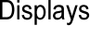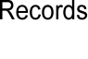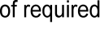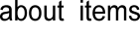

**3.0 TESTING:**

|  |  |  |  |  |
| --- | --- | --- | --- | --- |
| **FORM NAME** | **INPUT** | **EXPECTED**  **OUTPUT** | **ACTUAL**  **OUTPUT** | **STATUS** |
| **MAIN MENU FORM** | Menu Option | Show required Form | Required  Form was displayed | Pass |
| **MEMBERSHIPFORM** | Member details are  entered | Create new member  account | New Account was created | Pass |
| **LOGIN FORM** | Member ID and password | If password is correct, login. | Member authenticated for future  operations. | Pass |
| **ISSUE FORM** | Book ID | If books issued is less than three, issue the  book. | Book issued | Pass |
| **RETURN/REISSUE**  **FORM** | Book ID | Book returned/  reissued | Book returned/  Reissued | Pass |
| **BOOK ENQUIRY** | Book Name | Book details  are displayed | Book details  are displayed | Pass |

**4.0 SAMPLE FORMS**

MAIN MENU FORM

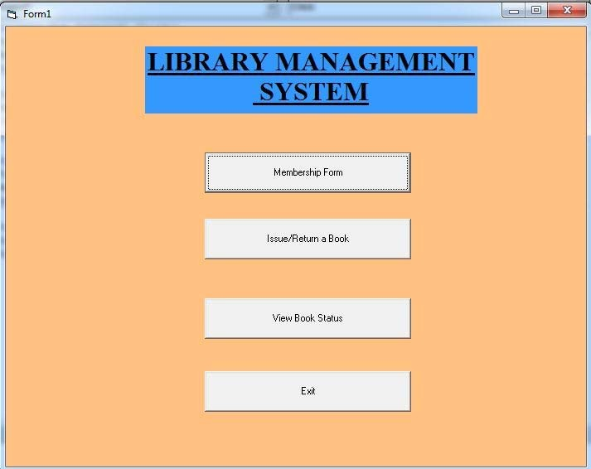

MEMBERSHIP FORM

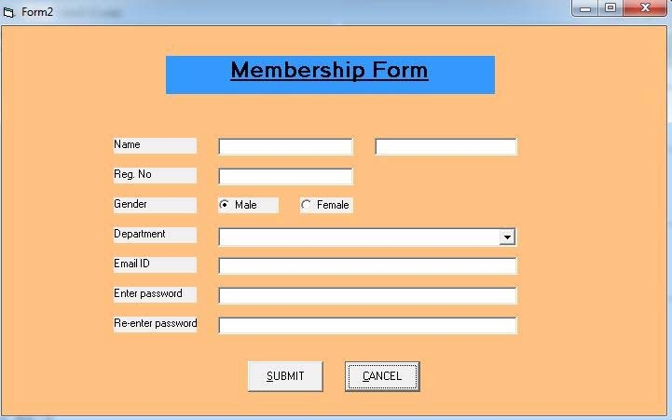

LOGIN FORM

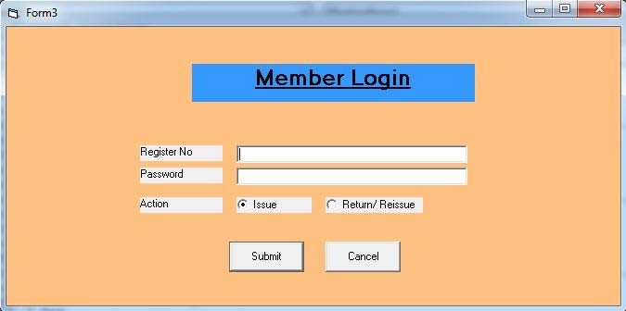

ISSUE FORM

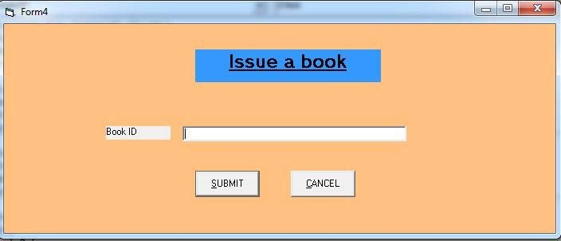

RETURN/REISSUE FORM

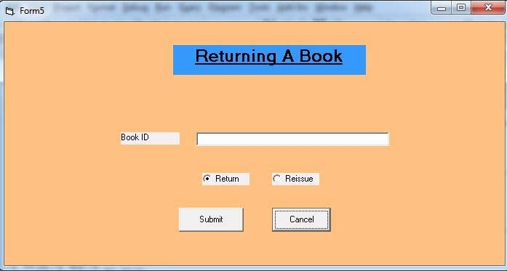

BOOK ENQUIRY FORM

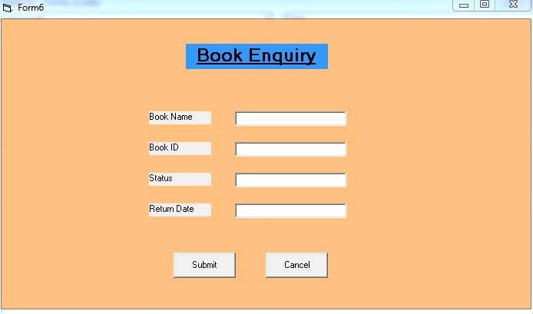

# 4.0 RESULT:

**Thus the online Library System was implemented using the specified front end and back end tools.**

**Ex No: 4 AUTOMATED BANKING SYSTEM**

* 1. **PROBLEM DEFINITION**

To develop an automated banking system, which is required to perform the following functions:

* 1. The customer logs into the system using card number and pin number. The system checks forvalidation.
  2. The system queries the customer for the type of account either fixed deposit or credit account. After getting the type of account the system shows the balance left.
  3. The system queries the customer for the transaction type either withdrawal or deposit and the required amount. The user enters the amount and the transaction if carries out

# SRS DOCUMENT FOR AUTOMATED BANKINGSYSTEM

* 1. **INTRODUCTION**
     1. Purpose
        1. The purpose of this SRS is to describe the requirements involved in developing an Automated Banking System (ABS).
        2. The intended audience is any person whowants
           1. To create account.
           2. To withdraw or deposit either in fixed deposit or credit account.
     2. Scope
        1. The product is titled Automated Banking System(ABS).
        2. The product will perform the followingtasks
           1. Allow a new user to create an account, either fixed or credit account by entering the details and by depositing an initial amount.
           2. Allow the existing user to enter his account details like card number, pin number and account type to view hisbalance.
           3. Allow the existing user to deposit an amount by entering the amount to be deposited after the balance had beenviewed.
           4. Allow the existing user to withdraw an amount by entering the amount to be withdrawn after the balance had beenviewed.
           5. The primary benefits expected of the system are: user friendly, continuous connectivity without failure, fault tolerant and involves lessermanpower.
     3. Definitions, Acronyms andAbbreviations
        1. ABS: Automated BankingSystem.
     4. References
        1. IEEE standard 830-1998 recommended practice for Software RequirementsSpecifications-Description.
        2. IEEE Software Requirements Specifications Template[http://www.cas.master.ca/~carette/SE3M04/2003/files/](http://www.cas.master.ca/%7Ecarette/SE3M04/2003/files/) srs_template.doc
     5. Overview

2.1.54.1 The SRS contains an analysis of the requirements necessary to help easy design.

* + - 1. The overall description provides interface requirements for the Banking system, product perspective, hardware interfaces, software interfaces, communication interface, memory constraints, product functions, user characteristics and otherconstraints.
      2. Succeeding pages illustrate the characteristics of typical naïve users accessing the system along with legal and functional constraints enforced that affect banking system in anyfashion.

# THE OVERALLDESCRIPTION

* + 1. Product perspective
       1. Hardware interfaces
          1. Hard disk: The database connectivity requires a hardware configuration that is on-line. This makes it necessary to have a fast database system (such as any RDBMS) running on high rpm hard-disk permitting complete data redundancy and backup systems to support the primary goal ofreliability.
          2. The system must interface with the standard output device, keyboard and mouse to interact with thissoftware.
       2. Software interfaces
          1. Back End: MS Access2007
          2. Front End: Microsoft Visual Basic 6.0
       3. Operations
          1. The user can create a newaccount.
          2. The existing user can access his account and view his balance by entering hisdetails.

2.2.1.3.2 The user can deposit and withdraw money from his account.

* + 1. Product Functions
       1. Creating a New Account

The user should provide his personal details to facilitate the bank clerk to create a new account. The user shouldprovide:

* + - * 1. CustomerName.
        2. Customeraddress.
        3. Required accounttype.
        4. PinNumber.
        5. Initialdeposit.
      1. Operating with created account

The user should be able to operate with his new account after:

* + - * 1. Entering cardnumber.
        2. Entering pin number.
        3. Entering the account type, transaction type and amount involved in thetransaction.
    1. Usercharacteristics
       1. The intended users of this software need not have specific knowledge as to what is the internal operation of the system. Thus the end user is at a high level of abstraction that allows easier, faster operation and reduces the knowledge requirement of enduser
       2. The Product is absolutely user friendly, so the intended users can be the naïveusers.
       3. The product does not expect the user to possess any technical background. Any person who knows to use the mouse and the keyboard can successfully use thisproduct.
    2. Constraints:
       1. At the time of creating the new account, each user gives a pin number and is provided with a unique card number that must be used for further transactions. Hence the user is required to remember or store these numberscarefully.
       2. At the time of creating the new account, the initial deposit should not be less than the specified amount.

# SPECIFICREQUIREMENTS

* + 1. Logical DatabaseRequirements
       1. The system should contain databases that include all the necessary information for the product to function according to the requirements. These include relations such as Customer Details and AccountDetails.
       2. Customer details refer to the customer’s name and address. Account details of the customer include the card number, account type, transaction type and the pin number given by the user to be used at the time of the transaction at the bank.

# FRONT – ENDDESCRIPTION

The front end for the Automated Banking System (ABS) is designed using Microsoft Visual Basic 6.0. The front end contains a user-friendly interface. The first form contains a welcome screen that provides an option for the user to either crate a new account or to operate through an existing account. The “create account” module contains a provision to create a new account after collecting the customer name, address and other details. The card number and pin number of the user is obtained every time there is a transaction. The user is requested to select the required type of transaction and the amount involved in thetransaction.

# BACK – ENDDESCRIPTION

The Automated Banking System (ABS) database contains only one table. It correlates a unique card number, customer name, account type, pin number and the balance.

# DATASTRUCTURES

2.6.1. ACCOUNT DETAILS

|  |  |  |
| --- | --- | --- |
| **FIELD NAME** | **TYPE** | **CONSTRAINTS** |
| NAME | TEXT |  |
| ACC_NO | AUTONUMBER | NOT NULL |
| AGE | NUMBER |  |
| GENDER | TEXT |  |
| EMAIL | TEXT |  |
| PHONE_NO | NUMBER |  |
| PASSWORD | TEXT |  |
| BALANCE | NUMBER |  |

# DATA FLOWDIAGRAM:



Display summary report

Queries for details

Commits transaction

Enters a/c number + pin number

Database

Update

Displaysreport on a/cdetails

Checks for availability

Enters details

Generates error report

about new transaction

User

Administrator

**3.0 TESTING**

|  |  |  |  |  |
| --- | --- | --- | --- | --- |
| **FORM NAME** | **INPUT** | **EXPECTED OUTPUT** | **ACTUAL OUTPUT** | **STATUS** |
| MAIN MENU FORM | Menu Option | Required Form must be displayed | Required form was displayed | Pass |
| ACCOUNT CREATION  FORM | User Details are entered | Create a new account | New account was created | Pass |
| LOGIN FORM | Account ID and password are entered | If passwords match, login | User permitted to perform further operations | Pass |
| WELCOME FORM | User can select deposit, withdraw or view balance | Show Deposit form or Withdraw form or view balance | Deposit form or withdraw form or balance is displayed | Pass |
| DEPOSIT FORM | Amount to be deposited is entered | Deposit amount | Amount was deposited | Pass |
| WITH DRAW FORM | Amount to be withdrawn is  Entered | Withdraw amount | Amount was withdrawn | Pass |

**4.0 SAMPLEFORMS**

MAIN MENUFORM

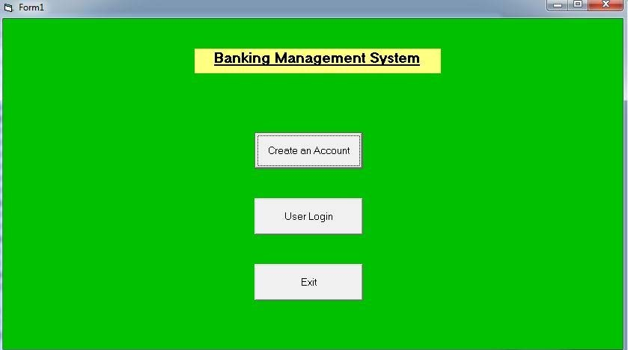

# ACCOUNT CREATION FORM

LOGIN FORM

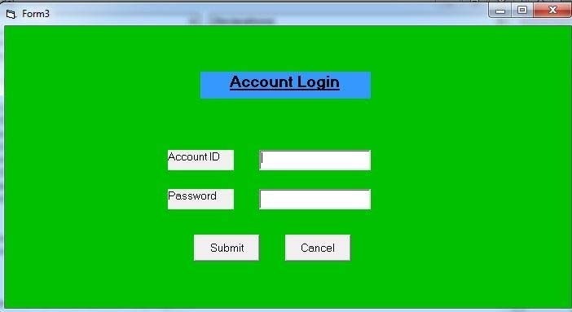

**W**ELCOME FORM

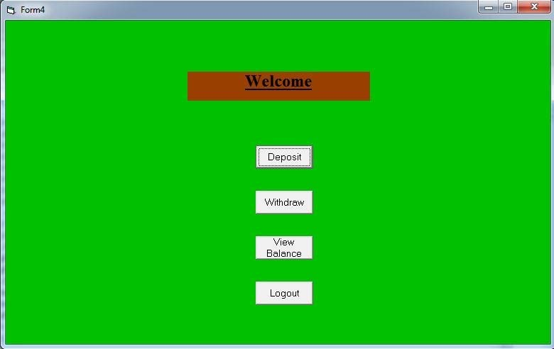

DEPOSIT FORM

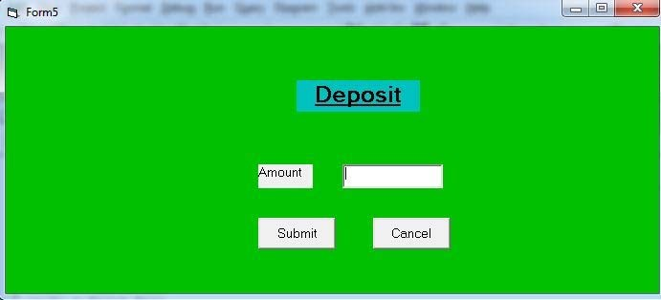

WITHDRAW FORM

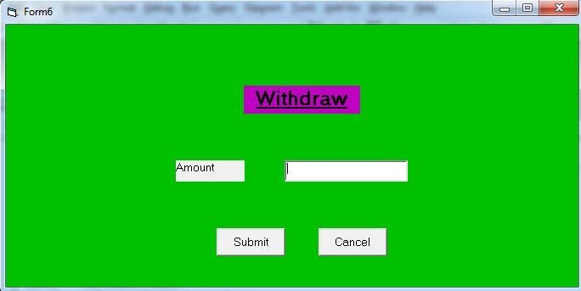

# 5.0 RESULT

**Thus the requirements involved in developing an Automated Banking System was completed successfully**

**Ex No: 5 AIRLINE RESERVATION SYSTEM**

* 1. **PROBLEM DEFINITION**

Ticket reservation system for airlines has to be developed. The system developed should contain the following features

* + 1. The system should contain the followingfeatures
    2. Search for information about the flight by means of flight number and destination
    3. While displaying information about the flight it has to provide availability of seats.
    4. While reserving tickets the system obtain following information from theuser

Passenger Name, Sex, Age, Address. Credit Card Number, Bank Name.

Flight number, Flight name, Date of Journey and number of tickets to be booked.

* + 1. Based on the availability of tickets, the ticket has to be issued. The ticket issued should contain the following information –ticket number, flight no, flight name, date of journey, number of passengers, sex, age and departure time.
    2. Cancellation of booked tickets should beavailable.

# SRS DOCUMENT FOR AIRLINE RESERVATIONSYSTEM

* 1. **INTRODUCTION**
     1. Purpose
        1. The purpose of this SRS is to describe the requirements involved in developing a Airline Reservation system(ARS).
        2. The intended audience is any person who wants to reserve or cancel tickets or to check the availability of Airlinetickets
     2. Scope
        1. The product is titled Airline Reservation system(ARS).
        2. The product will perform the followingtasks
           1. The software that is being developed can be used to check the availability of the flight tickets for the specified flight, destination and date ofjourney
           2. If the tickets are available to the users needs and specification, then the software provide a facility to book thetickets.
           3. If the passengers wants to cancel the tickets, he can use the cancellation module of the Airline ReservationSystem.
     3. Definitions, Acronyms andAbbreviations
        1. ARS: Airline ReservationSystem.
     4. References
        1. IEEE standard 830-1998 recommended practice for Software RequirementsSpecifications-Description.
     5. Overview
        1. The SRS contains an analysis of the requirements necessary to help easy design.
        2. The overall description provides interface requirements for the Airline Reservation system, product perspective, hardware interfaces software interfaces,, communication interface, memory constraints, product functions, user characteristics and otherconstraints.
        3. Succeeding pages illustrate the characteristics of typical naïve users accessing the system along with legal and functional constraints enforced that affect Airline Reservation system in anyfashion.

# THE OVERALLDESCRIPTION

* + 1. Product perspective
       1. Hardware interfaces
          1. Hard disk: The database connectivity requires a hardware configuration with a fast database system running on high rpm hard-disk permitting complete data redundancy and back-up systems to support the primary goal ofreliability.
          2. The system must interface with the standard output device, keyboard and mouse to interact with thissoftware.
       2. Software interfaces
          1. Back End: MS Access2007
          2. Front End: Microsoft Visual Basic 6.0
       3. Operations
          1. The user mode enables the end-users to do the end user operations like checking the availability, reserving and canceling of flight tickets.
    2. Product Functions
       1. Viewing FlightDetails

The user must have the access up-to-date information about the flights including

* + - * 1. Flightnumber
        2. FlightName
        3. Flight route(Start and Destinationstations)
        4. Flighttimings
        5. Seat availability.
      1. Reserving Tickets

The user must be able to reserve tickets after selecting 2.2.2.2.1Flight number

2.2.2.2.2 Flight Route

* + - 1. Canceling Tickets

The user must be able to cancel tickets that he has earlier reserved by quoting the ticket number, credit card number and bank name.

* + 1. Usercharacteristics
       1. The intended users of this software need not have specific knowledge as to what is the internal operation of the system. Thus the end user is at a high level of abstraction that allows easier, faster operation and reduces the knowledge requirement of enduser
       2. The Product is absolutely user friendly, so the intended users can be the naïveusers.
       3. The product does not expect the user to possess any technical background. Any person who knows to use the mouse and the keyboard can successfully use thisproduct.
    2. Constraints
       1. At the time of reservation, each user is provided a unique ticket number that must be used for further operation like cancellation. Hence the user is required to remember or store this numbercarefully.

# SPECIFICREQUIREMENTS

* + 1. Logical DatabaseRequirements
       1. The system should contain databases that include all necessary information for the product to function according to the requirements. These include relations such as flight details, reservation details, and cancellationdetails.
       2. The user details refer to the information such as flight number and name, start and destination stations, seatavailability.
       3. Reservation details refer to personal information that is obtained from theuser
       4. At the time of reservation, the passenger is provided a unique ticket no that could be used at the time ofcancellation.
       5. While displaying any information about the flight it has to provide the followinginformation

Flight no and name

Availability of seats for the particular flight The flight timing

The passenger personal details should be obtained for reserving the tickets.

# FRONT – END DESCRIPTION

The front-end for the Airline Reservation system (ARS) is designed using Microsoft Visual Basic 6.0. The front-end contains a user- friendly interface. The first form contains a welcome screen that provides an option for the user to select one of the following

Enquiry Reservation Booking details Cancellation

In the Enquiry form the user can get details of the flight by means of either flight name destination or date 0of journey. In the reservation form, there can book details by entering the personal details. The ticket is displayed with details about the flight name and number, number of passengers, ticket number, sex and age. The cancellation form helps the user to cancel a ticket, which he had bookedearlier.

# BACK – ENDDESCRIPTION

The Airline Reservation system consists of two tables. One contains the flight details such as the flight name, flight number, destination, date of journey and seats available in each class that is referred to during enquiry. The other table has the passenger details such as name, age, sex, credit card number, and bank name. This table is referred to at the time of reservation or cancellation.

# DATASTRUCTURES

* + 1. FLIGHTDETAILS

|  |  |  |
| --- | --- | --- |
| **FIELD NAME** | **TYPE** | **CONSTRAINTS** |
| ROUTE_NAME | TEXT | NOT NULL |
| FLIGHT_NO | NUMBER | NOT NULL |
| SEATS_AVAIL | NUMBER |  |
| JOURNEY_DATE | DATE/TIME |  |
| DEP_TIME | DATE/TIME |  |
| ARR_TIME | DATE/TIME |  |
| COST | NUMBER |  |

* + 1. PASSENGER DETAILS

|  |  |  |
| --- | --- | --- |
| **FIELD NAME** | **TYPE** | **CONSTRAINTS** |
| TICKET_NO | AUTONUMBER | NOT NULL |
| NAME | TEXT | NOT NULL |
| GENDER | TEXT |  |
| ADDRESS | TEXT |  |
| CC_NO | NUMBER | NOT NULL |
| BANK_NAME | TEXT |  |
| NO_OF_TICKETS | NUMBER |  |

# DATA FLOWDIAGRAM

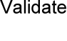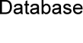

**3.0 TESTING:**

|  |  |  |  |  |
| --- | --- | --- | --- | --- |
| **FORM NAME** | **INPUT** | **EXPECTED OUTPUT** | **ACTUAL OUTPUT** | **STATUS** |
| MAIN MENU FORM | Menu Option | Required Form  must be displayed | Required form was displayed. | Pass |
| TICKET AVAILABILITY FORM | Flight route or Flight name | Flight seats availability  must be displayed | Flight seats availability are displayed. | Pass |
| RESERVATION FORM | Personal details were entered. | Ticket must be booked and  database updated. | Ticket was booked and  database was updated. | Pass |
| CANCELLATION FORM | Ticket number was entered. | Ticket must be cancelled and  database must be updated. | Ticket was cancelled and  database was updated.. | Pass |

**4.0 SAMPLE FORMS**

MAIN MENU FORM

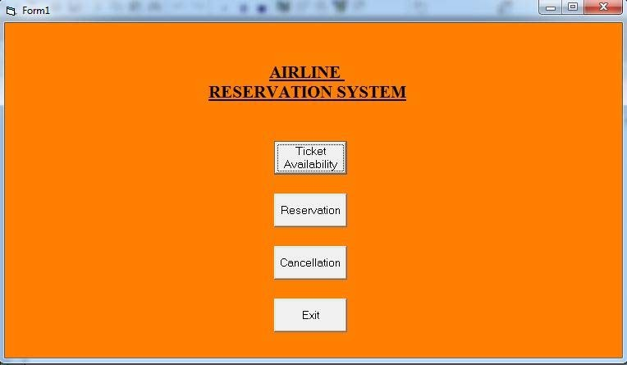

TICKET AVAILABILITY FORM

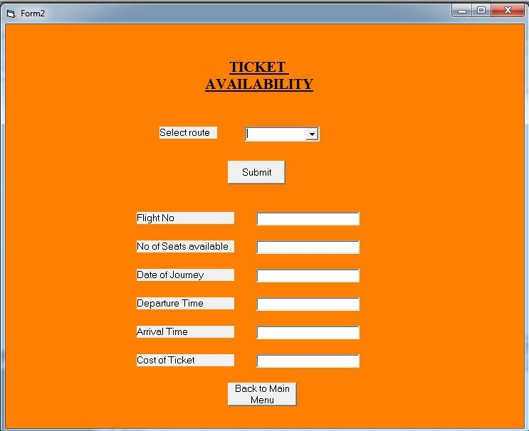

RESERVATION FORM

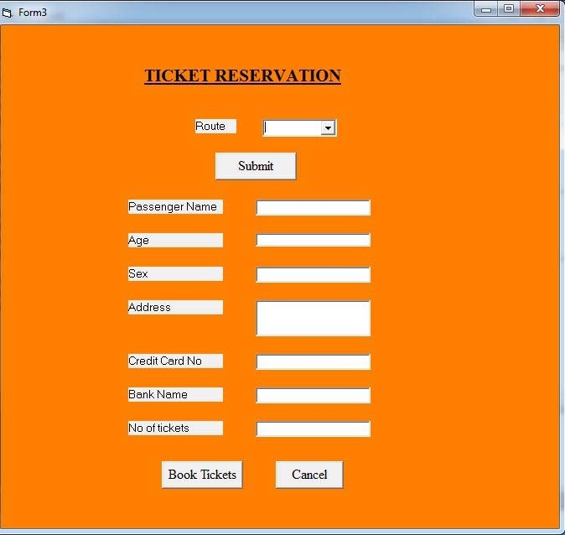

CANCELLATION FORM

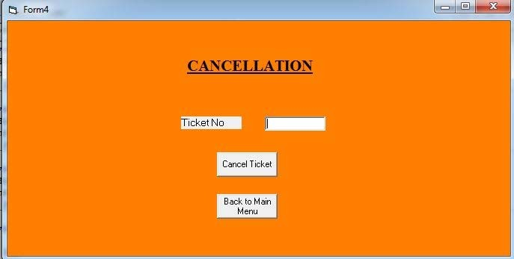

# 5.0 RESULT

**Thus the online Airline Reservations System was implemented using the specified front end and back end tools.**

**Ex No: 6 EMPLOYEE MANAGEMENT APPLICATION**

* 1. **PROBLEM DEFINITION**

A payroll application is to be developed which is required to perform the following functions:

* 1. It must provide a user in employee mode with the details of an employee, which includes his name, department, date of joining andsalary.
  2. It must validate an user to enter in administrator mode using password. It must provide a user to enter in administrator mode to view or modify an employee’s details using his employee ID. It must also allow the user to add a new employee and delete records of an existingemployee.

# SRS DOCUMENT EMPLOYEE MANAGEMENTAPPLICATION

* 1. **INTRODUCTION**
     1. Purpose
        1. The purpose of this SRS is to describe the requirements involved in developing a system to manage employee records.
        2. The intended audience is any person whowants
           1. To check employee details (both employee and administratormode).
           2. To add new employee, modify any employee’s details or delete records for the employee (only administer mode).
     2. Scope
        1. The product is titled Employee Management Application(EMA).
        2. The product will perform the followingtasks
           1. Allow either an employee or an administrator to view employee details.
           2. Allow the administrator to add a new employee with corresponding details.
           3. Allow the administrator to modify the detail of anemployee.
           4. Allow the administrator to delete the records for anemployee.
     3. Definitions, Acronyms andAbbreviations
        1. EMA: Employee ManagementApplication.
     4. References
        1. IEEE standard 830-1998 recommended practice for Software RequirementsSpecifications-Description.
     5. Overview
        1. The SRS contains an analysis of the requirements necessary to help easy design.
        2. The overall description provides interface requirements for the Employee Management System, product perspective, hardware interfaces, software interfaces, communication interface, memory constraints, product functions, user characteristics and other constraints.
        3. Succeeding pages illustrate the characteristics of typical naïve users accessing the system along with legal and functional constraints enforced that affect Employee Management Application in any fashion.

# THE OVERALLDESCRIPTION

* + 1. Product perspective
       1. Hardware interfaces
          1. Hard disk: The database connectivity requires a hardware configuration that is on-line. This makes it necessary to have a fast database system (such as any RDBMS) running on high rpm hard-disk permitting complete data redundancy and back- up systems to support the primary goal ofreliability.
          2. The system must interface with the standard output device, keyboard and mouse to interact with thissoftware.
       2. Software interfaces
          1. Back End: MS Access2007
          2. Front End: Microsoft Visual Basic 6.0
       3. Memory Constraints
          1. No specific constraints onmemory.
       4. Operations
          1. The software allows two modes ofoperations

The administrator mode allows user to add a new employee, modify the existing details of an employee, view the details of an employee and also delete records for an existingemployee.

* + 1. Product Functions
       1. Viewing the employee details

The user (both administrator and employee) must have the access to Up-to-date information about the employee including

* + - * 1. Employee Id
        2. EmployeeName
        3. EmployeeDepartment
        4. Date ofJoining
        5. Salary
      1. Adding a new employee

The user (only in administrator mode) must be able to add a new employee by supplying the following employee details.

* + - * 1. EmployeeName
        2. EmployeeDepartment
        3. Date ofJoining
        4. Salary
      1. Modifying the details of an employee

The user (only in administrator mode) must be able to modify the following details of an existing employee.

* + - * 1. EmployeeName
        2. EmployeeDepartment
        3. Date ofJoining
        4. Salary
    1. Usercharacteristics
       1. The intended users of this software need not have specific knowledge as to what is the internal operation of the system. Thus the end user is at a high level of abstraction that allows easier, faster operation and reduces the knowledge requirement of enduser
       2. The Product is absolutely user friendly, so the intended users can be the naïveusers.
       3. The product does not expect the user to possess any technical background. Any person who knows to use the mouse and the keyboard can successfully use thisproduct.
    2. Constraints
       1. At the time of adding a new employee, each employee must be assigned a unique ID number.

# SPECIFICREQUIREMENTS

* + 1. Logical DatabaseRequirements
       1. There is only one database which contains all the necessary information about an employee which includes employee ID, employee name, department, date if joining andsalary.

# FRONT – ENDDESCRIPTION

The front end for the Employee Management Application (EMA) is designed using Microsoft Visual Basic 6.0. The front – end contains a user – friendly interface. It has a welcome screen that provides an option for the user to enter in employee mode or in administrator mode. In employee mode the user can enter the employee ID of the employee and view his details. The user has to validate him self using password to enter in administrator mode. In administrator mode, apart form viewing the details the user can also add a new employee by providing details or modify the existing details using the employee ID.

# BACK – ENDDESCRIPTION

There is only one table. It correlates a unique employee ID with his name, department, date of joining and salary.

# DATASTRUCTURES

2.6.1. EMPLOYEE DETAILS

|  |  |  |
| --- | --- | --- |
| **FIELD NAME** | **TYPE** | **CONSTRAINTS** |
| ID | AUTONUMBER | NOT NULL |
| NAME | TEXT |  |
| DEPT | TEXT |  |
| JOIN_DATE | DATE/TIME |  |
| SALARY | NUMBER |  |

# DATA FLOWDIAGRAM

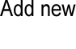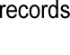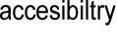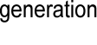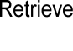

**3.0 TESTING**

|  |  |  |  |  |
| --- | --- | --- | --- | --- |
| **FORM NAME** | **INPUT** | **EXPECTED OUTPUT** | **ACTUAL OUTPUT** | **STATUS** |
| MAIN MENU | Menu Option | Required Form  must be displayed | Required Form was displayed | Pass |
| ADD NEW EMPLOYEE | Employee details | Add employee details to database | Employee details was updated to database | Pass |
| VIEW  EMPLOYEE DETAILS | Employee ID | Show Employee Details | Employee  details was displayed | Pass |
| MODIFY EMPLOYEE  DETAILS | Employee ID | Modify employee  details | Employee details was  modified | Pass |
| DELETE EMPLOYEE DETAILS | Employee ID | Delete Employee Details | Employee details was  deleted from database | Pass |

**4.0 SAMPLE FORMS**

MAIN MENU

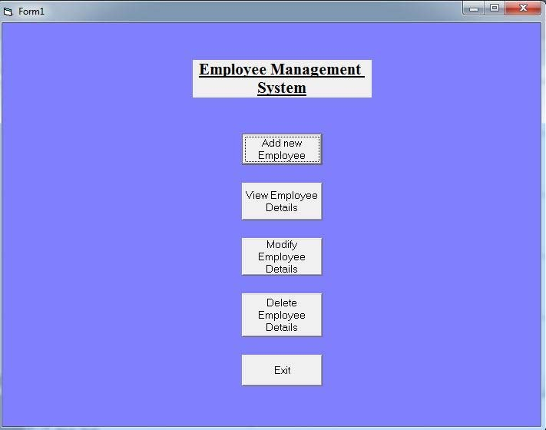

ADD NEW EMPLOYEE

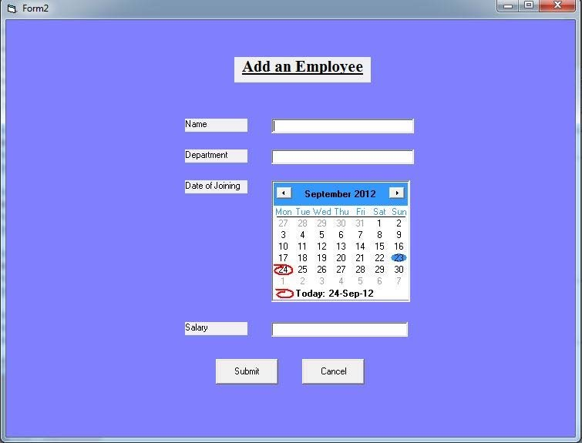

VIEW EMPLOYEE DETAILS

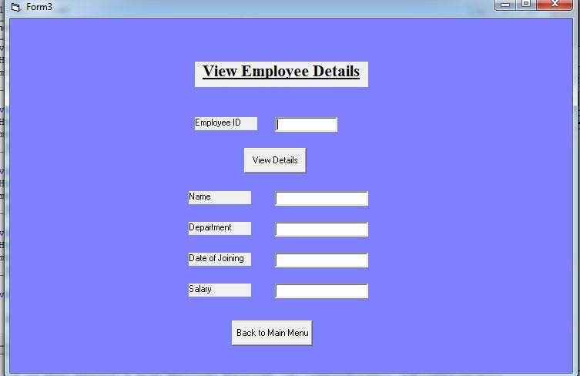

MODIFY EMPLOYEE DETAILS

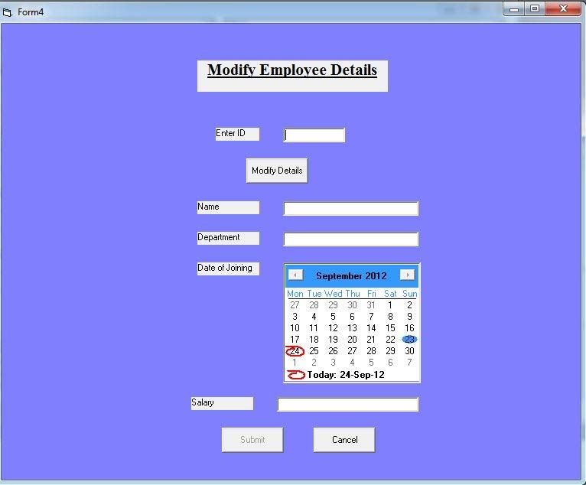

DELETE EMPLOYEE DETAILS

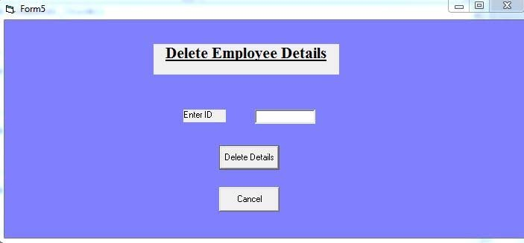

# 5.0 RESULT

**Thus the Employee Management System was implemented using the specified front end and back end tools.**

**Ex No: 7 HOSPITAL MANAGEMENT APPLICATION**

* 1. **PROBLEM DEFINITION**

A hospital application is to be developed which is required to perform the following functions:

* 1. It must provide a user in admin mode with the details of apatient,doctor.
  2. It must provide a user in doctor mode who can modify the details of the illness and thetreatment.

# SRS DOCUMENT HOSPITAL MANAGEMENTAPPLICATION

* 1. **INTRODUCTION**
     1. Purpose
        1. The purpose of this SRS is to describe the requirements involved in developing a system to manage hospitalrecords.
        2. The intended audience is any person whowants
           1. To check patient and doctor details (both doctor and administratormode).
           2. To add new treatment details for any particular patient according to his illness. (onlydoctormode).
     2. Scope
        1. The product is titled Hospital Management Application(HMA).
        2. The product will perform the followingtasks
           1. Allow either an doctor or an administrator to view patientdetails.
           2. Allow the administrator to add a new patient, doctor with corresponding details.
           3. Allow the administrator to modify the detail of anpatient,doctor.
           4. Allow the doctor to add the records for an ongoingtreatment.
     3. Definitions, Acronyms andAbbreviations
        1. HMA: Hospital ManagementApplication.
     4. References
        1. IEEE standard 830-1998 recommended practice for Software RequirementsSpecifications-Description.
     5. Overview
        1. The SRS contains an analysis of the requirements necessary to help easy design.
        2. The overall description provides interface requirements for the Hospital Management System, product perspective, hardware interfaces, software interfaces, communication interface,memory

constraints, product functions, user characteristics and other constraints.

* + - 1. Succeeding pages illustrate the characteristics of typical naïve users accessing the system along with legal and functional constraints enforced that affect Hospital Management Application in anyfashion.

# THE OVERALLDESCRIPTION

* + 1. Product perspective
       1. Hardware interfaces
          1. Hard disk: The database connectivity requires a hardware configuration that is on-line. This makes it necessary to have a fast database system (such as any RDBMS) running on high rpm hard-disk permitting complete data redundancy and back- up systems to support the primary goal ofreliability.
          2. The system must interface with the standard output device, keyboard and mouse to interact with thissoftware.
       2. Software interfaces
          1. Back End: MSAccess
          2. Front End: Microsoft Visual Basic 6.0
       3. Memory Constraints
          1. No specific constraints onmemory.
       4. Operations
          1. The software allows two modes ofoperations

The administrator mode allows user to add a new patient, doctor, modify the existing details of a patient & doctor, view the details of an Patient &doctor.

* + 1. Product Functions
       1. Patient Details

The user (both administrator and doctor) must have the access to Up-to-date information about the patient including

* + - * 1. PatientID
        2. PatientName
        3. PatientAge
        4. PatientAddress
        5. Admit and DischargeDate
      1. DoctorDetails

The user (only in administrator mode) must be able to add and view by supplying the following doctor details.

* + - * 1. Doctor ID
        2. DoctorName
        3. DoctorAge
        4. DoctorAddress
        5. DoctorQualification
      1. Illness Details

The user (only in doctor mode) must be able to modify the following details of an existing treatment.

* + - * 1. PatientID
        2. DoctorID
        3. Illness
        4. Medication
    1. Usercharacteristics
       1. The intended users of this software need not have specific knowledge as to what is the internal operation of the system. Thus the end user is at a high level of abstraction that allows easier, faster operation and reduces the knowledge requirement of enduser
       2. The Product is absolutely user friendly, so the intended users can be the naïveusers.
       3. The product does not expect the user to possess any technical background. Any person who knows to use the mouse and the keyboard can successfully use thisproduct.
    2. Constraints
       1. At the time of adding a new patient and doctor, each must be assigned a unique IDnumber.
       2. The ID numbers for the illness table must match the IDs in the respectivetables

# SPECIFICREQUIREMENTS

* + 1. Logical DatabaseRequirements
       1. There is one database which contains all the necessary information about a patient which includes patient ID, patient name, age, address, admit and discharge date

2.3.1.2. There is a database which contains all the necessary information about a doctor which includes doctor ID, doctor name, age, address, qualification.

2.3.1.3 There is a database which contains all the necessary information about a treatment which include Patient ID, doctor ID, illness, medication

# FRONT – ENDDESCRIPTION

The front end for the Hospital Management Application (HMA) is designed using Microsoft Visual Basic 6.0. The front – end contains a user – friendly interface. It has a welcome screen that provides an option for the user to enter in doctor mode or in administrator mode. The user has to validate him self using password to enter in administrator mode. In administrator mode, apart form viewing the details the user can

also add a new patient and doctor by providing details or modify the existing details using the patient ID and doctorID.

# BACK – ENDDESCRIPTION

There are 4 tables. The 1st one maintains login details for all the users. The 2nd table correlates a unique patient ID with his name, age, address, admit and discharge date.. The 3rd table correlates a unique doctor ID with his name, age, address and qualification. The 4th table correlates a doctor ID and patient ID with illness and medication

# DATASTRUCTURES

* + 1. LOGINDETAILS

|  |  |  |
| --- | --- | --- |
| **FIELD NAME** | **TYPE** | **CONSTRAINTS** |
| ID | NUMBER | NOT NULL |
| PASSWORD | TEXT | NOT NULL |

* + 1. PATIENTDETAILS

|  |  |  |
| --- | --- | --- |
| **FIELD NAME** | **TYPE** | **CONSTRAINTS** |
| ID | NUMBER | NOT NULL |
| FNAME | TEXT | NOT NULL |
| LNAME | TEXT |  |
| AGE | TEXT |  |
| ADDRESS | TEXT |  |
| INDATE | DATE/TIME |  |
| OUTDATE | DATE/TIME |  |

* + 1. DOCTORDETAILS

|  |  |  |
| --- | --- | --- |
| **FIELD NAME** | **TYPE** | **CONSTRAINTS** |
| ID | NUMBER | NOT NULL |
| FNAME | TEXT | NOT NULL |
| LNAME | TEXT |  |
| AGE | NUMBER |  |
| ADDRESS | TEXT |  |
| QUALIFICATION | TEXT |  |

* + 1. TREATMENTDETAILS

|  |  |  |
| --- | --- | --- |
| **FIELD NAME** | **TYPE** | **CONSTRAINTS** |
| PID | NUMBER | NOT NULL |
| DID | NUMBER | NOT NULL |
| ILLNESS | TEXT |  |
| MEDICINE | TEXT |  |

# E/RDIAGRAM

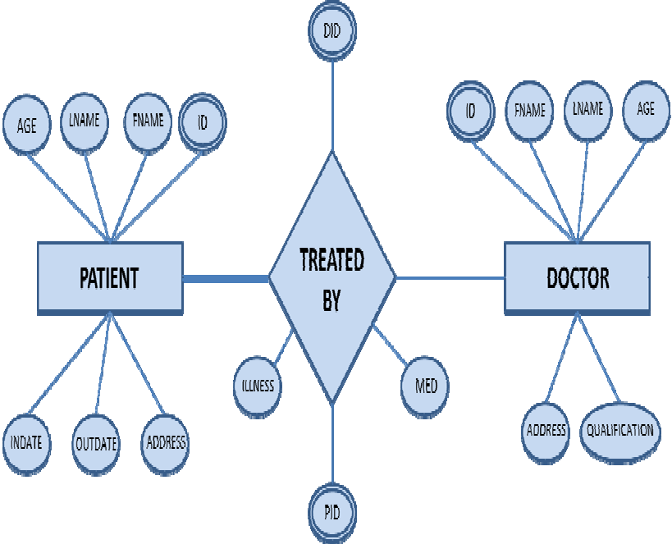

**3.0 TESTING**

|  |  |  |  |  |
| --- | --- | --- | --- | --- |
| **FORM NAME** | **INPUT** | **EXPECTED OUTPUT** | **ACTUAL OUTPUT** | **STATUS** |
| LOGIN FORM | ID and Password | If correct password, main menu must be displayed | If correct password, main menu was displayed | Pass |
| MAIN MENU FORM | Menu Option | Required Form must be  displayed | Required Form must be  displayed | Pass |
| PATIENT DETAILS FORM | Patient ID or Patient details | Patient details must be displayed or updated to database. | Patient details was displayed or updated to database | Pass |
| DOCTOR DETAILS FORM | Doctor ID | Doctor details must be displayed | Doctor details was displayed | Pass |
| TREATMENT DETAILS FORM | Patient ID, Doctor ID, Illness and  Medicines | Treatment details must be updated to  database | Treatment details was updated to  database | Pass |

**4.0 SAMPLE FORMS**

LOGIN FORM

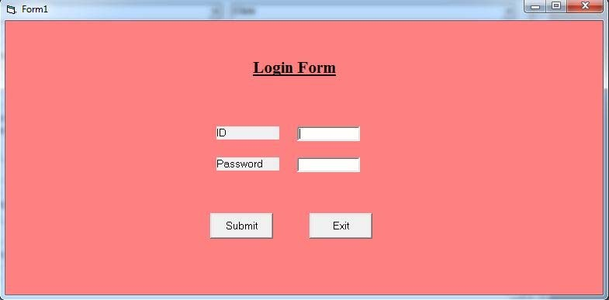

MAIN MENU FORM

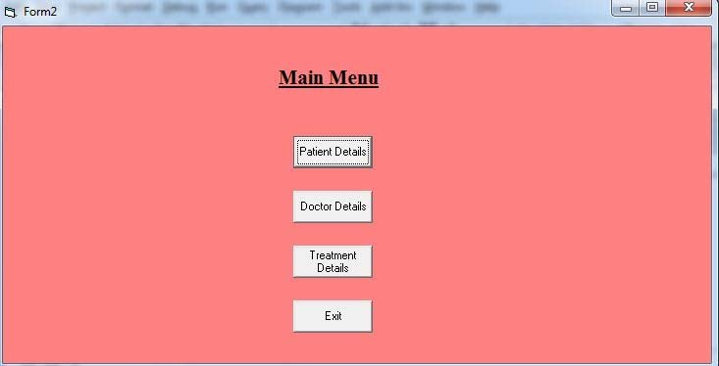

PATIENT DETAILSFORM

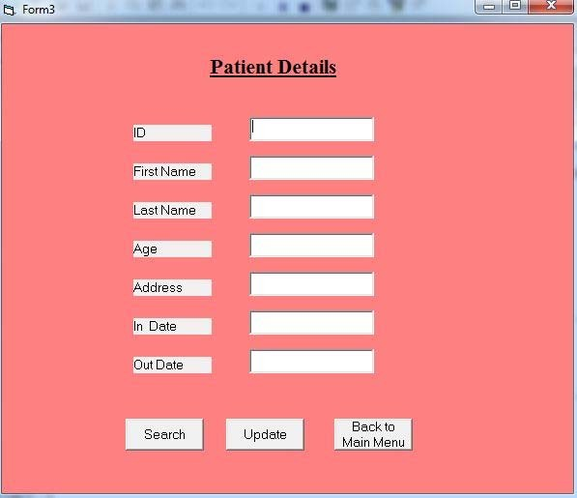

DOCTOR DETAILSFORM

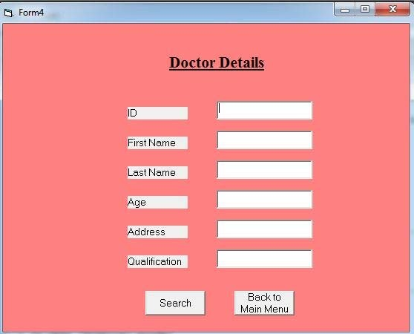

TREATMENT DETAILS FORM

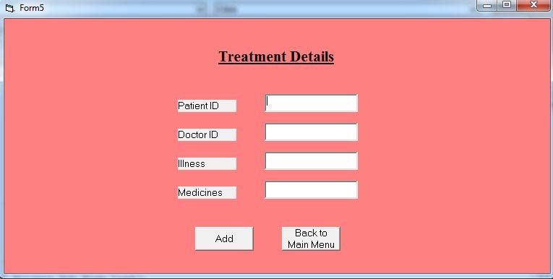

# 5.0 RESULT

**Thus the Hospital Management System was implemented using the specified front end and back end tools.**

**Ex No: 8 DEVELOPMENT OF A BLOOD BANK MANAGEMENT SYSTEM**

Blood bank is a place where blood bag that is collected from blood donation events is stored in one place. The term “blood bank” refers to a division of a hospital laboratory where the storage of blood product occurs and where proper testing is performed to reduce the risk of transfusion related events.

Online Blood Bank management system is to provide services for the people who need blood by getting help from the donors who are interested in donating blood for the people. Blood Bank donation system can collect blood from many donators in short from various sources and distribute that blood to needy people who require blood. To do all this we require high quality Web Application to manage those jobs.

**Problem Statement**

1. The first problem is to search for blood donation records. Staffs of the hospital have to search one-by-one and it may take a lot of time. Besides that, the paper records can be lost or undefined.
2. Location of blood donation campaign and planning. Donor usually heard the location for blood donation campaign from friends or family and cannot plan well for next donation.
3. The staffs of the hospitals are having difficulty to make report for total blood packet by monthly basis. Missing and duplicate blood donation information records make the count inaccurate and this will be problem to detect critical blood demand
4. One of the factors of the public afraid to donate their blood is they believe in myths. The myths that they always believe are, if they donate their blood they will become weak and pale. This system hopes to solve that problem by creating more awareness of the process of blood donation.
5. **System Requirement Specification (SRS)**
   1. **Purpose:**

* The main purpose of this application is to automate the complete operations of the blood bank.
* The intended audience is anyone working at a bloodbank who wants to keep track and maintain blood donation records
  1. **Scope:**
* The product is titled Blood Bank Management System(BBMS)
* The product will perform the following tasks:

1. Allow users to register for blood donation
2. Allow admin to maintain blood donation records of various different donors and blood group in a single system.
3. Allows super admin to manage admins so that there is no abuse of power.
   1. **Definitions, Acronyms andAbbreviations:**

* BBMS – Blood Bank Management System
  1. **References:**
* IEEE standard 830-1998 recommended practice for Software RequirementsSpecifications-Description.
* IEEE Software Requirements Specifications Template[http://www.cas.master.ca/~carette/SE3M04/2003/files/](http://www.cas.master.ca/%7Ecarette/SE3M04/2003/files/) srs_template.doc
  1. **Overview:**
* The SRS contains an analysis of the requirements necessary to help easy design.
* The overall description provides interface requirements for the Blood Bank ManagementSystem, product perspective, hardware interfaces, software interfaces, communication interface, memory constraints, product functions, user characteristics and otherconstraints.
* Succeeding pages illustrate the functions of typical users accessing the system along with the different functions available for the admins and super admins and the responsibilities they must share to make proper and efficient use of the Blood Bank Management System.

1. **Hardware and Software Requirements**

**Hardware Requirements:**

Processor : Intel Core Duo 2.0 GHz or more

RAM : 1 GB or More

Hard disk : 80GB or more

Monitor : 15” CRT, or LCD monitor

Keyboard : Normal or Multimedia

Mouse : Compatible mouse

**Software Requirements:**

1. XAMPP (Cross Platform(X) for Apache, MySQL, PHP and Perl)
2. Notepad
3. Google Chrome or Mozilla Firefox or Internet Explorer

**Languages Used:**

Front End : PHP

HTML

CSS

Back End : MySQL Database Server

Operating System : Windows 7 or above

1. **FRONT-END DESCRIPTION**

The proposed system (Blood Bank Management System) is designed to help the Blood Bank administrator to meet the demand of Blood by sending and/or serving the request for Blood as and when required. The proposed system gives the procedural approach of how to bridge the gap between Recipient, Donor, and Blood Banks. The system has a registration process wherein the user can register as a Donor. The system will provide the admin the option to look at the details of the Donor and verify the integrity of the user before either accepting or rejecting the user. The administrator can also alter all the system data. The Super Admin feature has been added to manage and control all admins so that there is no abuse or corruption of power.

1. **BACK-END DESCRIPTION**

There are 7 tables. The 1st table contains admin details such as username and password. The 2nd table contains information about blood donation camps. The 3rd table contains the user queries that are sent to the admin. It contains details such as name, email, mobile, subject and date. The 4th table contains the details of the registered blood donors. The 5th table contains the login credentials of the super admins whose main function is to manage the other admins. The 6th table contains the blood requests made by the recipients or hospitals. The req id is the primary key of the table and it is also auto incremented for every entry in the table. The 7th table contains all the blood groups. The bg attribute is also the primary key.

1. **DATA STRUCTURE**

**Admin (admin):**

|  |  |  |
| --- | --- | --- |
| **Attributes** | **Data Type** | **Constraints** |
| Username | varchar(100) | NOT NULL |
| Pwd | varchar(100) | NOT NULL |
| Adminname | varchar(100) | NOT NULL |

**Camps (camp):**

|  |  |  |
| --- | --- | --- |
| **Attributes** | **Data Type** | **Constraints** |
| camp id | int(100) | PRIMARY KEY(AUTO INCREMENT) |
| Campname | varchar(500) | NOT NULL |
| Organisedby | varchar(500) | NOT NULL |
| City | varchar(100) | NOT NULL |
| State | varchar(100) | NOT NULL |
| Detail | varchar(1000) | NOT NULL |

**Contact Us (contacts):**

|  |  |  |
| --- | --- | --- |
| **Attributes** | **Data Type** | **Constraints** |
| Name | varchar(100) | NOT NULL |
| Email | varchar(100) | NOT NULL |
| Mobile | varchar(100) | NOT NULL |
| Subj | varchar(100) | NOT NULL |
| Date | timestamp(5) | NOT NULL |

**Donors (registereddonors):**

|  |  |  |
| --- | --- | --- |
| **Attributes** | **Data Type** | **Constraints** |
| Donorid | int(100) | PRIMARY KEY(AUTO INCREMENT) |
| Name | varchar(100) | NOT NULL |
| Gender | varchar(10) | NOT NULL |
| Age | int(3) | NOT NULL |
| Mobile | varchar(10) | NOT NULL |
| b_g | varchar(15) | NOT NULL |
| Email | varchar(100) | NOT NULL |
| City | varchar(100) | NOT NULL |

**Super Admin (superadmin):**

|  |  |  |
| --- | --- | --- |
| **Attributes** | **Data Type** | **Constraints** |
| Username | varchar(100) | NOT NULL |
| Pwd | varchar(100) | NOT NULL |
| Adminname | varchar(100) | NOT NULL |

**Blood Request (requests):**

|  |  |  |
| --- | --- | --- |
| **Attributes** | **Data Type** | **Constraints** |
| Reqid | int(100) | PRIMARY KEY(AUTO INCREMENT) |
| Name | varchar(100) | NOT NULL |
| Gender | varchar(100) | NOT NULL |
| Age | int(3) | NOT NULL |
| Mobile | varchar(13) | NOT NULL |
| Bg | varchar(15) | NOT NULL |
| Email | varchar(100) | NOT NULL |
| Deadline | date | NOT NULL |
| Detail | varchar(500) | NOT NULL |

**Blood Group (bloodgroup):**

|  |  |  |
| --- | --- | --- |
| **Attributes** | **Data Type** | **Constraints** |
| Bg | varchar(100) | NOT NULL |

1. **DATA FLOW DIAGRAM (DFD)**

**LEVEL 0 DFD:**

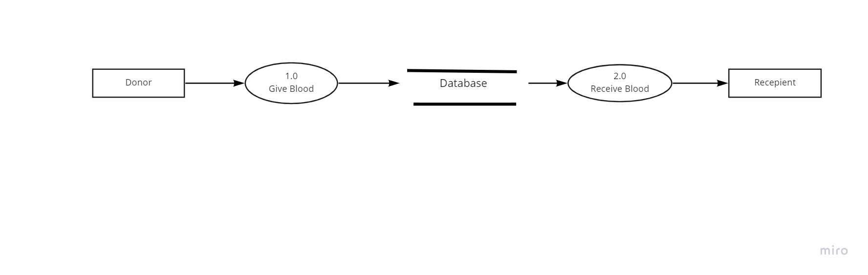

**LEVEL 1 DFD:**

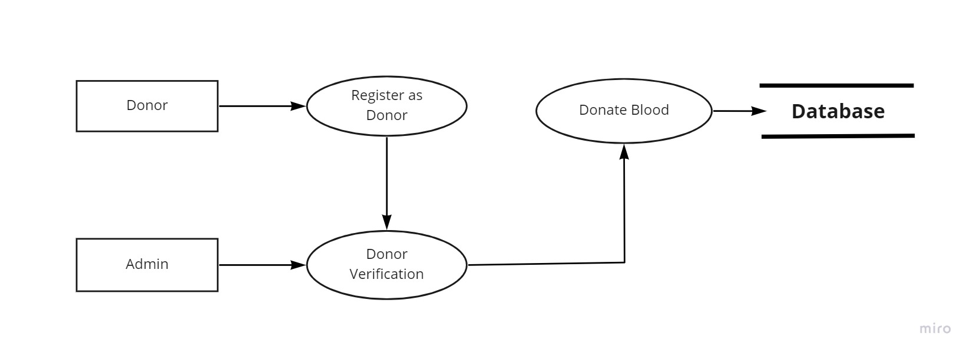

**LEVEL 2 DFD:**

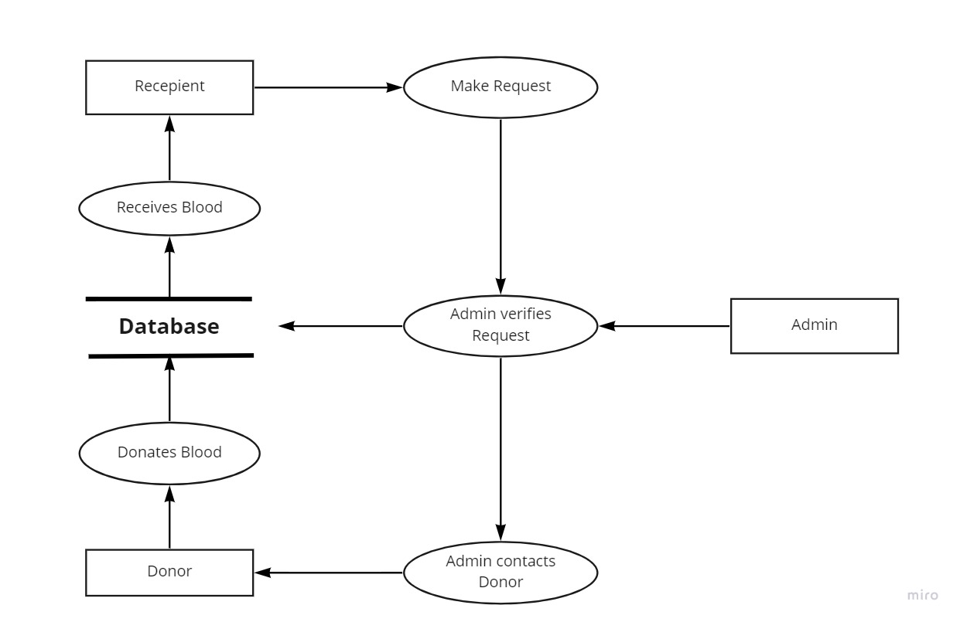

**E-R DIAGRAM FOR BLOODBANK:**

The E-R Diagram defines 6 different entities and their attributes along with the relationship between these entities. The entities are Donor, Blood, Blood Bank, Admin, Super Admin and Recipient. The relationship between these entities are as follows:

* Donor donates Blood
* Blood Bank Stores Blood
* Recipient receives Blood
* Admin Manages Blood Bank
* Super Admin Manages Admin

donate

Recipient

receives

Blood Bank

stores

Blood

manages

Admin

Donor

manages

Super Admin

**CLASS DIAGRAM:**



**Sample Forms:**

**Donor Registration Page:**

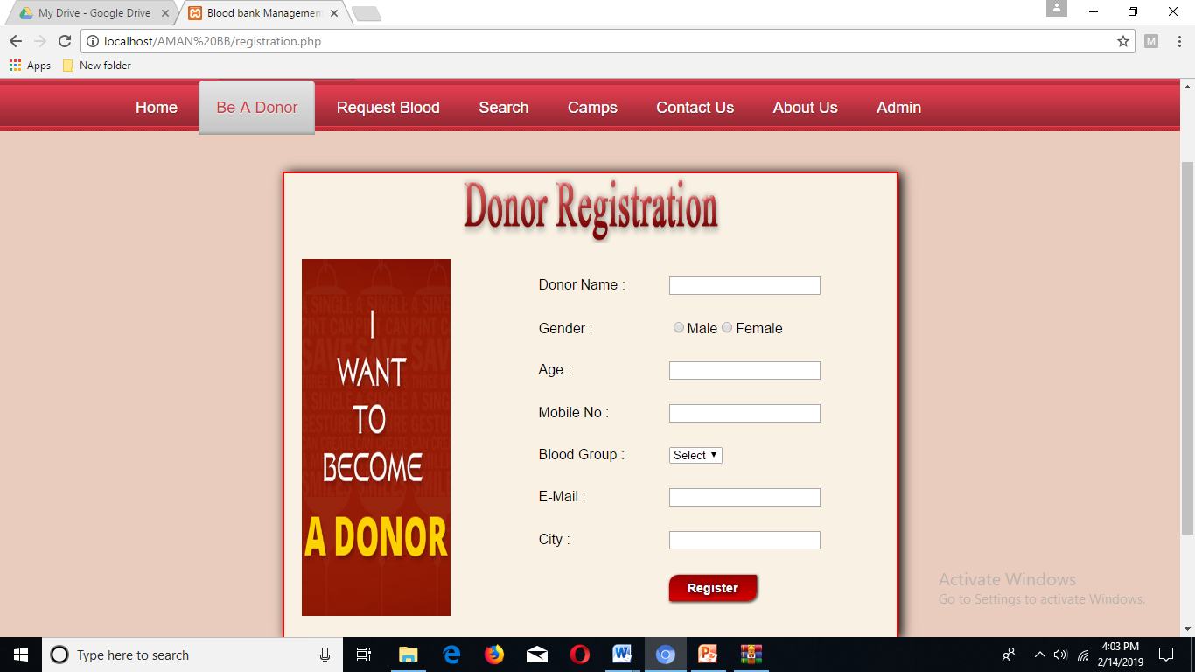

**Request Blood Page:**

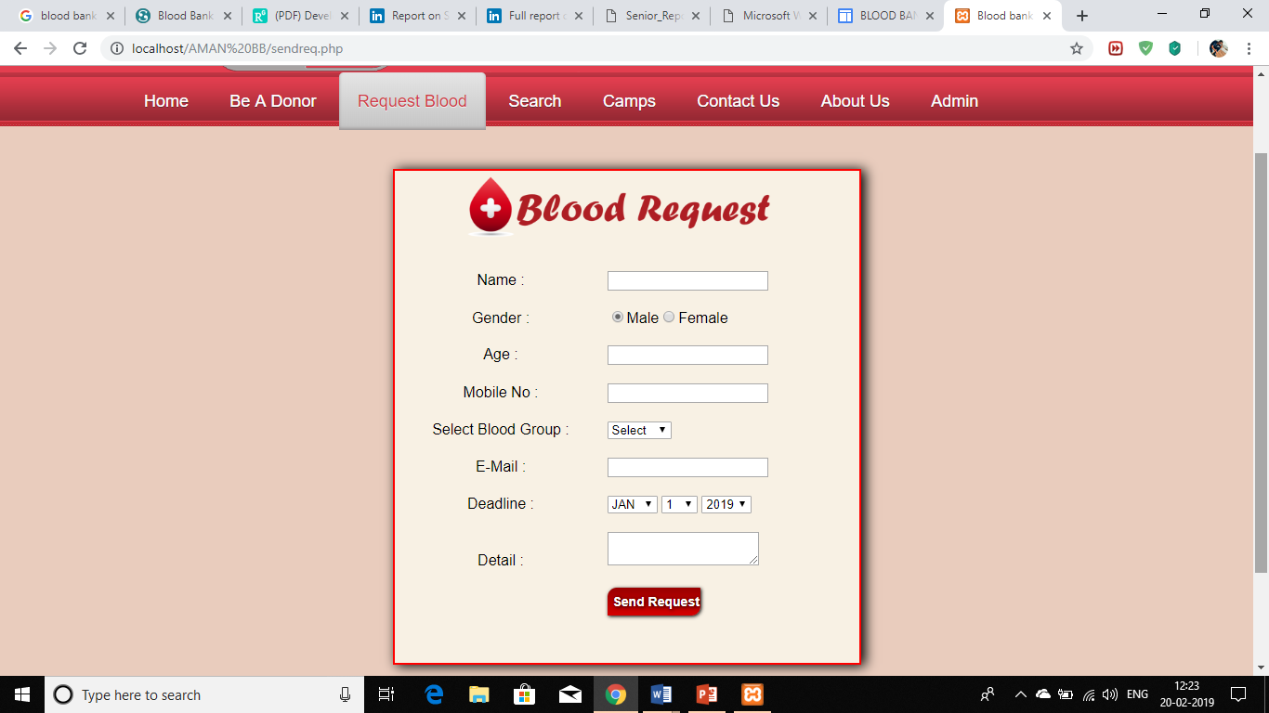

**Camps Page:**

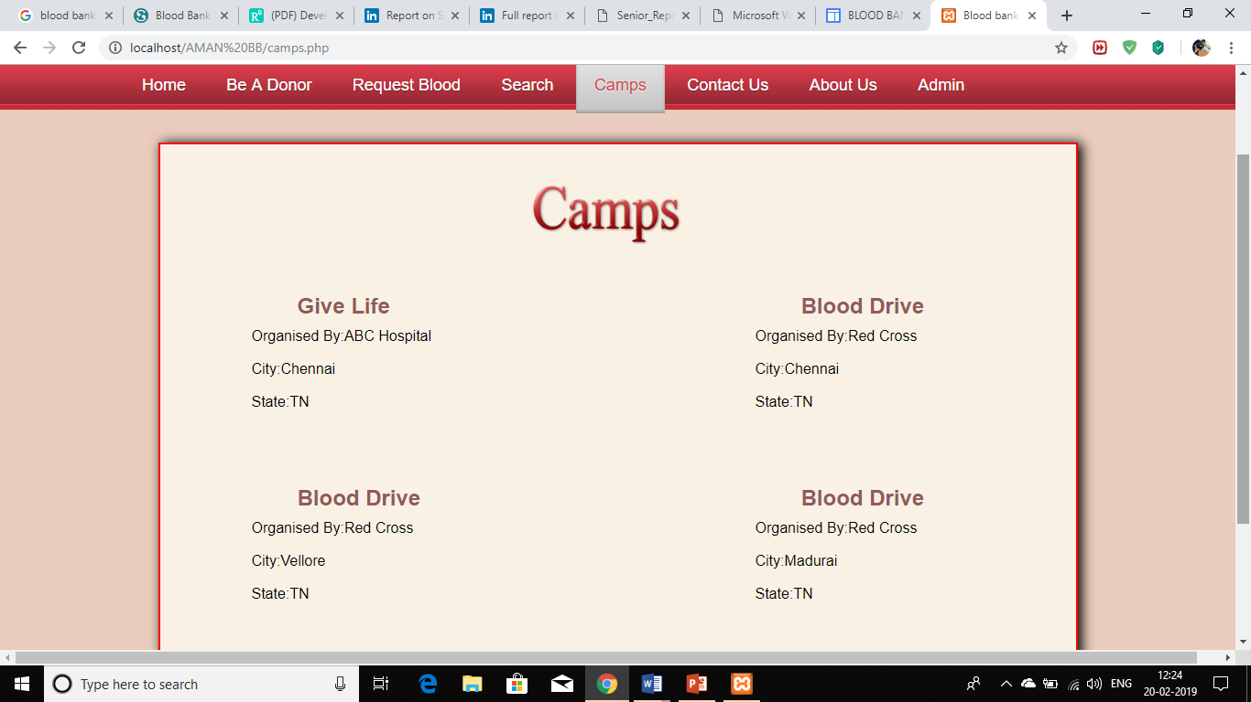

**Contact Us Page:**

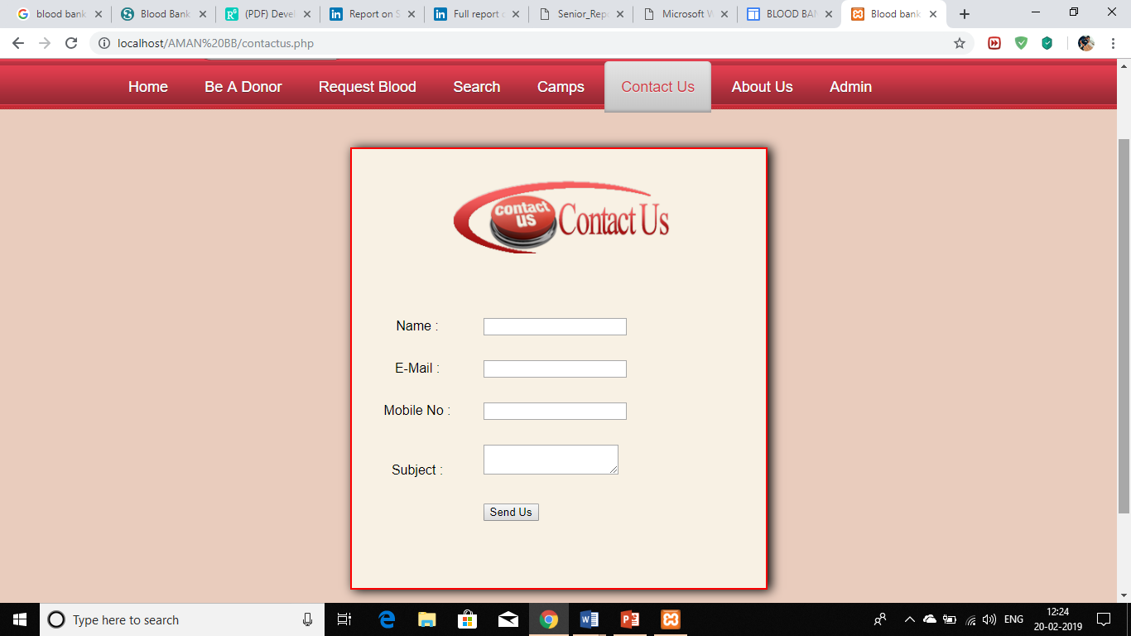

**About Us Page:**

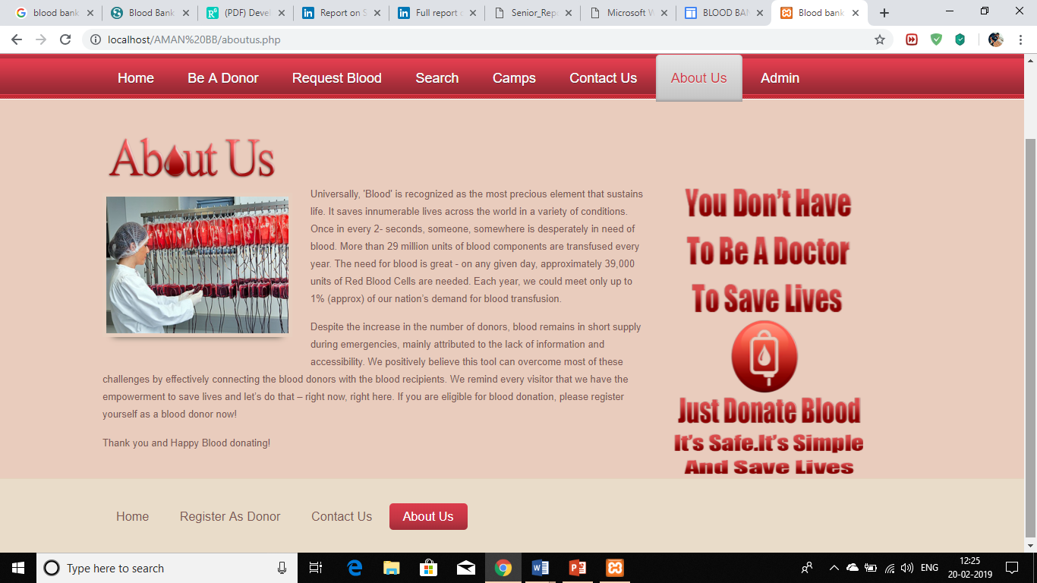

**Admin Log in Page:**

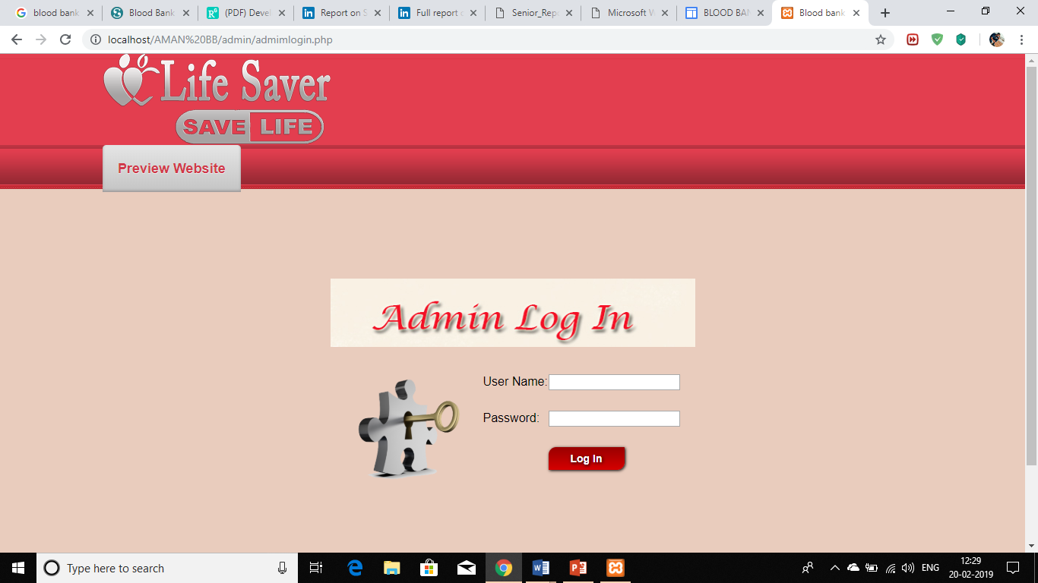

**The Donors Page:**

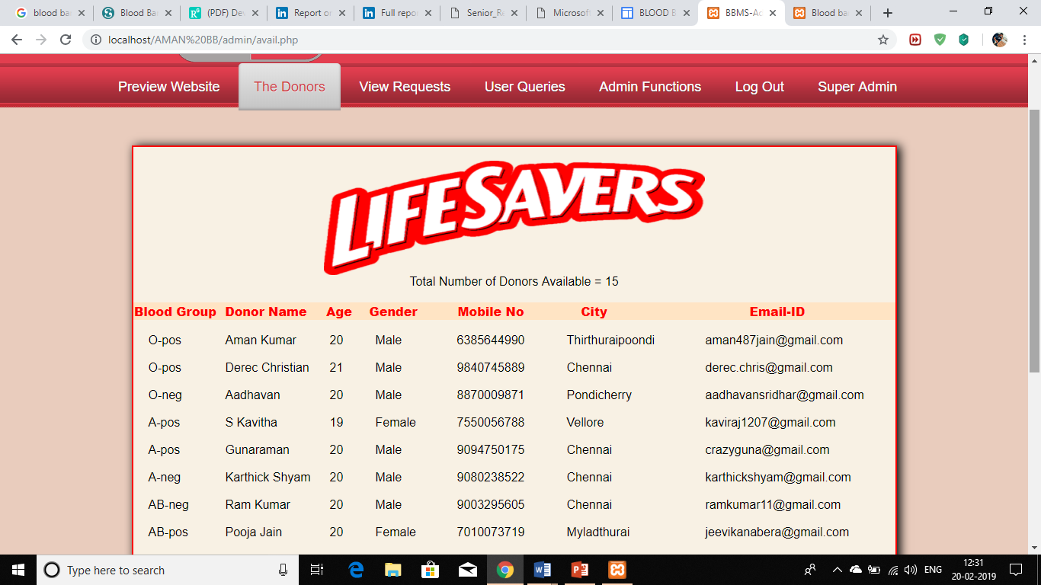

**View Requests Page:**

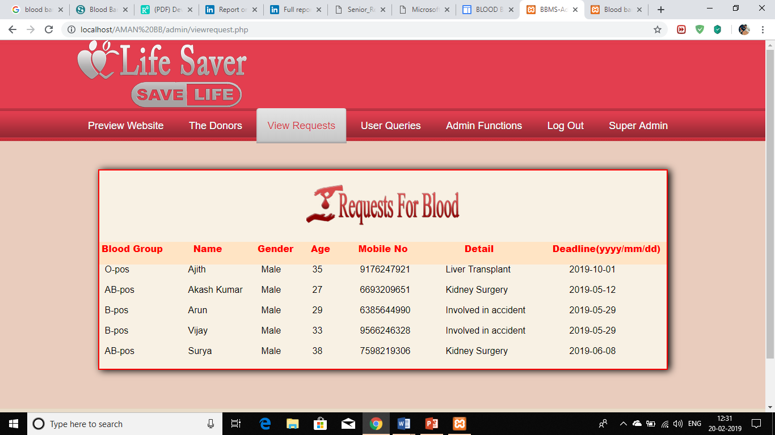

**Ex No: 9 COVID PATIENTS MANAGEMENT SYSTEM**

1. **PROBLEM DEFINITION** – This Application is developed to fight the Corona situation together and stronger.
   1. The COVID Patients Management System is useful for automating the Data Collection of COVID affected patients and have a track on them.
   2. Doctors/Specialists can enter the details of the patient who has been affected by COVID. The details include Patient Name, Age, Sex, Mobile number, Address, Date of test, Doctor.
   3. The Doctors will get an alert once in 15 days in order to track the patient if the age is less than 35 and 7 days if the age is more than 35. This will help the doctors to have a Health track on the patients.
   4. The patient will get an automated alert via SMS reminding them to take proper medicine an diet plan and after the verification of complete curation of the Patient, their data will automatically be sent to inactive history database
2. **SYSTEM REQUIREMENT SPECIFICATION (SRS)**

2.1 **Purpose:**

* The main purpose of this application is to automate the complete operations of the Hospital in managing Covid Patient Database.
* The intended audience is anyone working at a hospital who wants to keep track and maintain Covid Patient records

2.2 **Scope:**

1. The product is titled COVID Patients Management system
2. The product will perform the following tasks:
   * + - * Allow doctors to register
         * Allow admin/doctor to maintain Patient records of Covid Test and relevant details
         * Triggers and alert to the doctor 15 days/ 7 days once dependant on the age of the patient

2.3**Definitions, Acronyms andAbbreviations:**

1. CPMS – COVID Patient Management System

2.4 **Overview:**

The SRS contains an analysis of the requirements necessary to help easy design.

The overall description provides interface requirements for the COVID Patient Management System, product perspective, hardware interfaces, software interfaces, communication interface, memory constraints, product functions, user characteristics and otherconstraints.

Succeeding pages illustrate the functions of typical users accessing the system along with the different functions available for the admins and doctors of the hospital.

1. **Hardware and Software Requirements**

**Hardware Requirements:**

Processor : Intel Core Duo 2.0 GHz or more

RAM : 1 GB or More

Hard disk : 40GB or more

Monitor : 15” CRT, LCD or LED monitor

Keyboard : Normal or Multimedia

Mouse : Compatible mouse

**Software Requirements:**

XAMPP (Cross Platform(X) for Apache, MySQL, PHP and Perl)

Notepad

Google Chrome or Mozilla Firefox or Internet Explorer

**Languages Used:**

Front End : PHP

HTML

CSS

**Back End** : MySQL Database Server

**Operating System** : Windows 7 or above

1. **FRONT-END DESCRIPTION**

The proposed COVID Patients Management System is useful for automating the Data Collection of COVID affected patients and have a track on them.Doctors/Specialists can enter the details of the patient who has been affected by COVID. The details include Patient Name, Age, Sex, Mobile number, Address, Date of test, Doctor.The Doctors will get an alert once in 15 days in order to track the patient if the age is less than 35 and 7 days if the age is more than 35. This will help the doctors to have a Health track on the patients.The patient will get an automated alert via SMS reminding them to take proper medicine an diet plan and after the verification of complete curation of the Patient, their data will automatically be sent to inactive history database

1. **BACK-END DESCRIPTION**

There are 4 tables. The 1st table contains Admin/Doctor details such as username and password. The 2nd table contains information about COVID patientssuch as name, email, mobile,ID,age and date. The 3rd table contains the details of the Diet Plans for a Patient and SMS Management. The 4th table contains the Cured Patients database. Primary key is the Patient ID.

1. **DATA STRUCTRURE**

**Doctor/Admin :**

|  |  |  |
| --- | --- | --- |
| **Attributes** | **Data Type** | **Constraints** |
| Username | varchar(100) | PRIMARY KEY |
| Pwd | varchar(100) | NOT NULL |
| Ad/docname | varchar(100) | NOT NULL |

**Covid Patient :**

|  |  |  |
| --- | --- | --- |
| **Attributes** | **Data Type** | **Constraints** |
| Name | varchar(100) | NOT NULL |
| Email | varchar(100) | NOT NULL |
| Mobile | varchar(100) | NOT NULL |
| Age | varchar(100) | NOT NULL |
| Date Admitted | timestamp(5) | NOT NULL |
| PID | varchar(100) | PRIMARY KEY |

**Diet Plan :**

|  |  |  |
| --- | --- | --- |
| **Attributes** | **Data Type** | **Constraints** |
| PID | varchar(100) | PRIMARY KEY |
| Breakfast | varchar(100) | NOT NULL |
| Lunch | varchar(100) | NOT NULL |
| Dinner | varchar(100) | NOT NULL |

**Cured Patient :**

|  |  |  |
| --- | --- | --- |
| **Attributes** | **Data Type** | **Constraints** |
| Name | varchar(100) | NOT NULL |
| Email | varchar(100) | NOT NULL |
| Mobile | varchar(100) | NOT NULL |
| Age | varchar(100) | NOT NULL |
| Date Admitted | timestamp(5) | NOT NULL |
| PID | varchar(100) | PRIMARY KEY |

1. **ER DIAGRAM**

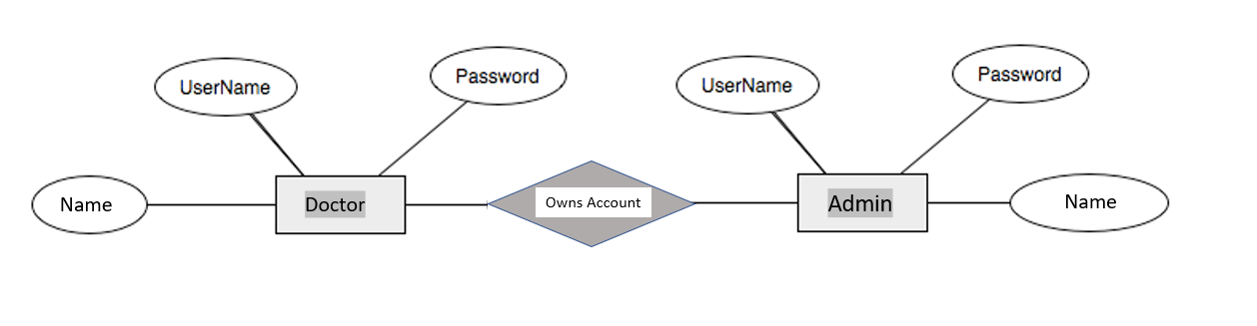

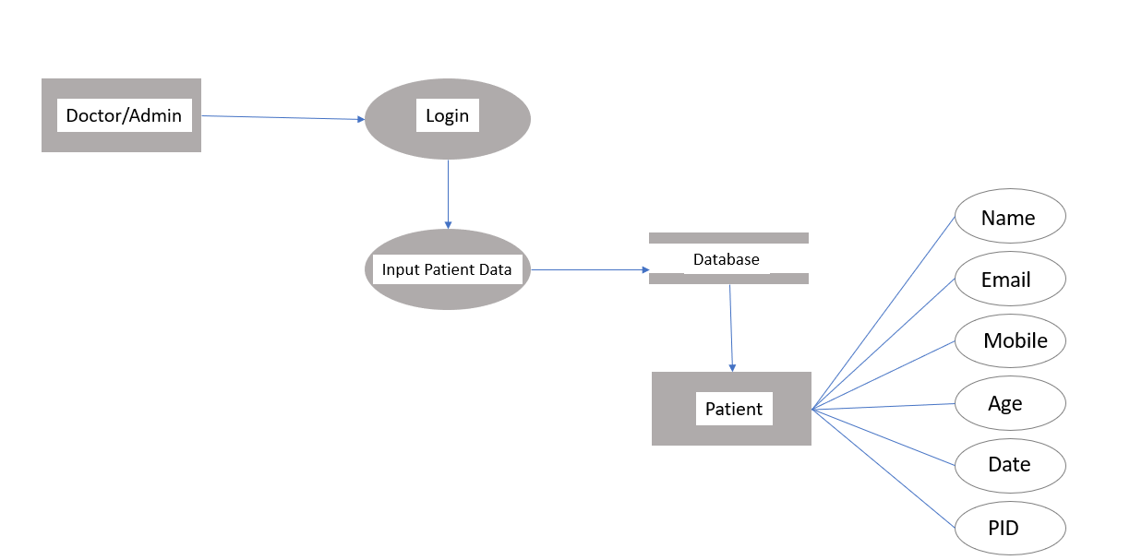

1. **DATA FLOW DIAGRAM**

**LEVEL 0 DFD**

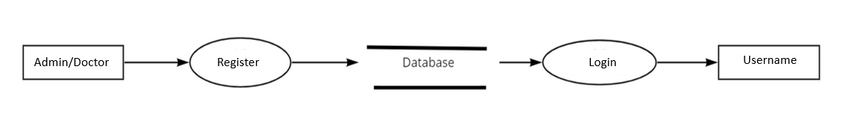

**LEVEL 1 DFD**

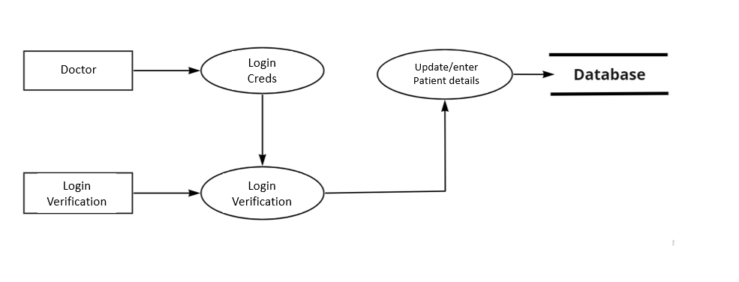

**LEVEL 2 DFD**

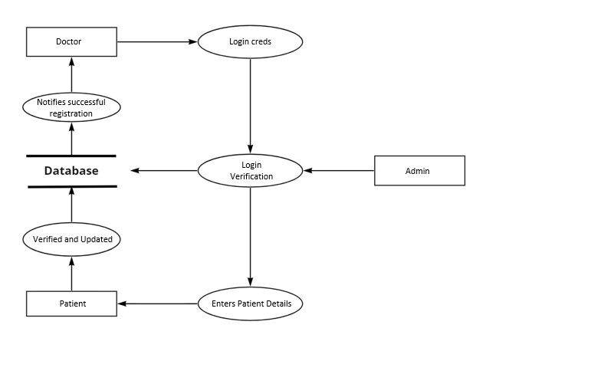

1. **SAMPLE SCREENSHOTS**

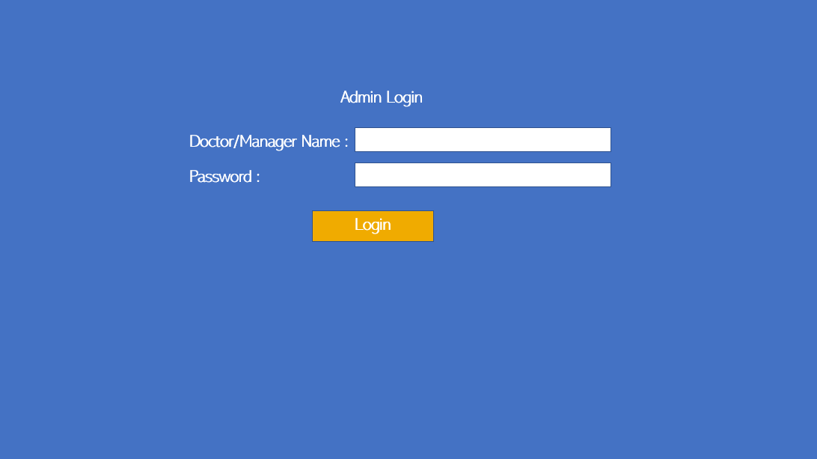

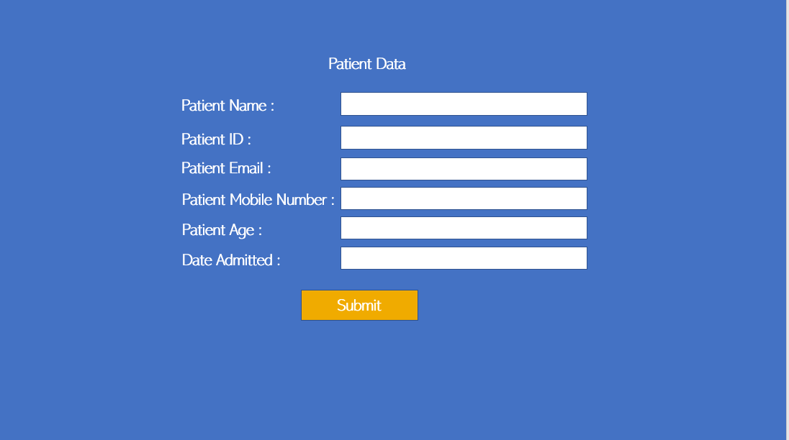

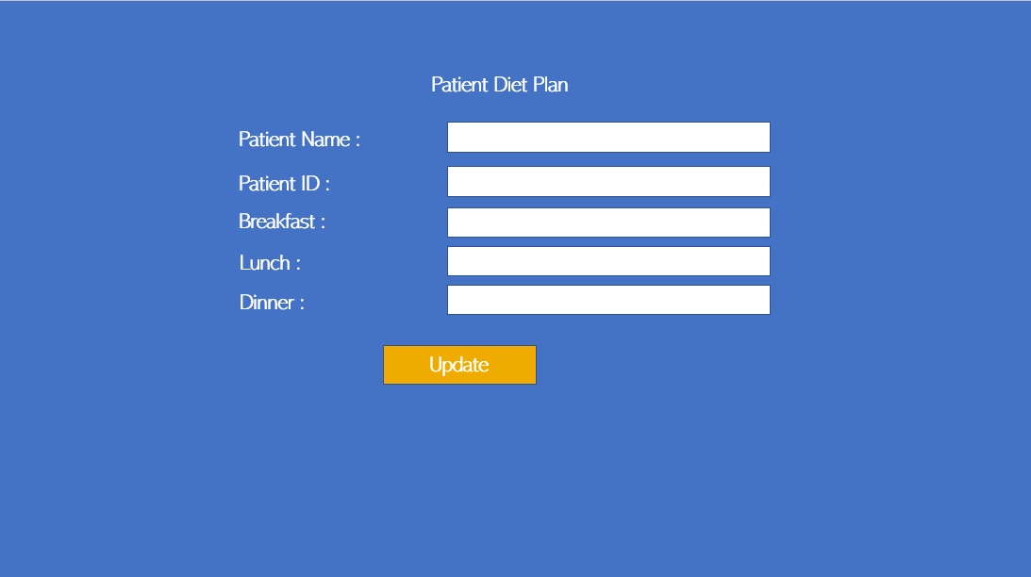

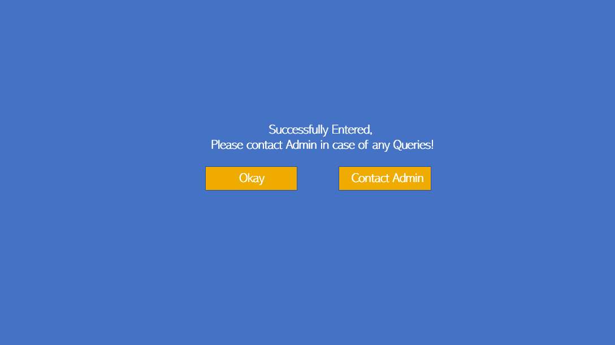

**Ex No: 10 RESTAURANT TABLE MANAGEMENT SYSTEM**

Restaurant table management system is a application where a customer can pre-book a table and also will be able to pay their bills through online payment.

In The other end the Hotel management will be able to promote their restaurant and will receive the customer needs and also the table reservations can be done

**Problem Statement**

1. The application is useful for the restaurants to provide the customers with the seamless billing and reservation experience
2. The hotel management team or the manager will be able to look for a free table from the application once when the customers enter the restaurant and can assign them with a table free with respect to their group strength
3. The server for that particular table will be able to get the order and will be able to feed the dishes ordered by the members of the table and will be saved in the database of that particular table. The server or the management will be able to add or edit the menu with respect to the members decision
4. Once when the meal is done, the bill will be auto generated once when the server or the management team clicks on end session and will provide the final bill amount. The server will then set the table's status to "under cleaning "and once when it is done, the table will will be back to available status and can be assigned to other customers entering the restaurant.
5. **System Requirement Specification (SRS)**

**1.1 Purpose:**

* The main purpose of this application is to automate the complete operations of the Restaurant table Management.
* The intended audience is anyone working at a Restaurant who wants to keep track and maintain Table booking.

**1.2Scope:**

* The product is Restaurant Table Management System (RTMS)
* The product will perform the following tasks:

1. Allow users to book the table
2. Allow admin to maintain reservation of tables from different customers and pay the bill in a single system.
3. Allows super admin to manage admins so that there is no abuse of power

.

**1.3 Definitions, Acronyms andAbbreviations:**

RTMS– Restaurant Table Management System

**1.4 References:**

* IEEE standard 830-1998 recommended practice for Software RequirementsSpecifications-Description.
* IEEE Software Requirements Specifications Template[http://www.cas.master.ca/~carette/SE3M04/2003/files/](http://www.cas.master.ca/%7Ecarette/SE3M04/2003/files/) srs_template.doc
  1. **Overview:**
* The SRS contains an analysis of the requirements necessary to help easy design.The overall description provides interface requirements for the Restaurant Table Management System, product perspective, hardware interfaces, software interfaces, communication interface, memory constraints, product functions, user characteristics and otherconstraints.
* Succeeding pages illustrate the functions of typical users accessing the system along with the different functions available for the admins and super admins and the responsibilities they must share to make proper and efficient use of the Restaurant Table Management System.

**2 Hardware and Software Requirements**

**Hardware Requirements:**

Processor : Intel Core Duo 2.0 GHz or more

RAM : 1 GB or More

Hard disk : 80GB or more

Monitor : 15” CRT, or LCD monitor

Keyboard : Normal or Multimedia

Mouse : Compatible mouse

**Software Requirements:**

1. XAMPP (Cross Platform(X) for Apache, MySQL, PHP and Perl)
2. Notepad
3. Google Chrome or Mozilla Firefox or Internet Explorer

**Languages Used:**

Front End : PHP

HTML

CSS

Back End : MySQL Database Server

Operating System : Windows 7 or above

1. **FRONT-END DESCRIPTION**

The proposed system (Restaurant Table Management System) is designed to help the customers book the table and pay the bill . The proposed system gives the procedural approach of how to bridge the gap between Customer, hotel management and bank .The system has a registration process wherein the user can register as a Customer. The system will provide the admin the option to look at the details of the customer and verify the integrity of the hotel management before either accepting or rejecting the table reservation. The administrator can also alter all the system data. The Super Admin feature has been added to manage and control all admins so that there is no abuse or corruption of power.

1. **BACK-END DESCRIPTION**

There are 7 tables. The 1st table contains admin details such as username and password. The 2nd table contains information about Registered Restaurants. The 3rd table contains the user queries that are sent to the admin. It contains details such as name, email, mobile, subject and date. The 4th table contains the details of the registered Customers . The 5th table contains the login credentials of the super admins whose main function is to manage the other admins. The 6th table contains the Food requests made by the customer and Restaurants. The req id is the primary key of the table and it is also auto incremented for every entry in the table. The 7th table contains all the nearby available hotels. The bg attribute is also the primary key.

1. **DATA STRUCTURE**

**Admin (admin):**

|  |  |  |
| --- | --- | --- |
| **Attributes** | **Data Type** | **Constraints** |
| Username | varchar(100) | PRIMARY KEY(AUTO INCREMENT) |
| Pwd | varchar(100) | NOT NULL |
| Adminname | varchar(100) | NOT NULL |

**Restaurant Names (Hotel):**

|  |  |  |
| --- | --- | --- |
| **Attributes** | **Data Type** | **Constraints** |
| Restaurant ID | int(100) | PRIMARY KEY(AUTO INCREMENT) |
| Restaurant name | varchar(500) | NOT NULL |
| Manager name | varchar(500) | NOT NULL |
| City | varchar(100) | NOT NULL |
| State | varchar(100) | NOT NULL |
| Detail | varchar(1000) | NOT NULL |

**Contact Us (contacts):**

|  |  |  |
| --- | --- | --- |
| **Attributes** | **Data Type** | **Constraints** |
| Name | varchar(100) | NOT NULL |
| Email | varchar(100) | NOT NULL |
| Mobile | varchar(100) | PRIMARY KEY(AUTO INCREMENT) |
| Subj | varchar(100) | NOT NULL |
| Date | timestamp(5) | NOT NULL |

**Customors (registeredcustomers):**

|  |  |  |
| --- | --- | --- |
| **Attributes** | **Data Type** | **Constraints** |
| Customerid | int(100) | PRIMARY KEY(AUTO INCREMENT) |
| Name | varchar(100) | NOT NULL |
| Gender | varchar(10) | NOT NULL |
| Age | int(3) | NOT NULL |
| Mobile | varchar(10) | NOT NULL |
| b_g | varchar(15) | NOT NULL |
| Email | varchar(100) | NOT NULL |
| City | varchar(100) | NOT NULL |

**Super Admin (superadmin):**

|  |  |  |
| --- | --- | --- |
| **Attributes** | **Data Type** | **Constraints** |
| Username | varchar(100) | PRIMARY KEY(AUTO INCREMENT) |
| Pwd | varchar(100) | NOT NULL |
| Adminname | varchar(100) | NOT NULL |

**Table Reservation (Pre booking table ):**

|  |  |  |
| --- | --- | --- |
| **Attributes** | **Data Type** | **Constraints** |
| Reqid | int(100) | PRIMARY KEY(AUTO INCREMENT) |
| Name | varchar(100) | NOT NULL |
| Gender | varchar(100) | NOT NULL |
| Age | int(3) | NOT NULL |
| Mobile | varchar(13) | NOT NULL |
| Headcount | int(3) | NOT NULL |
| Email | varchar(100) | NOT NULL |
| Deadline | date | NOT NULL |
| Detail | varchar(500) | NOT NULL |

1. **DATA FLOW DIAGRAM (DFD)**

**LEVEL 0 DFD:**

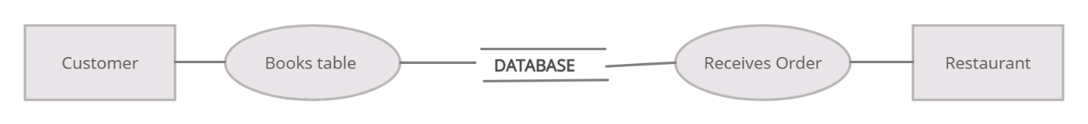

**LEVEL 1 DFD**

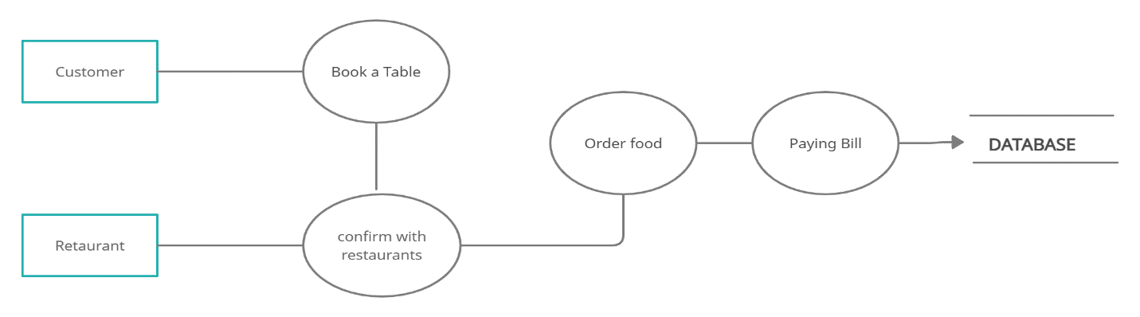

**LEVEL2DFD**

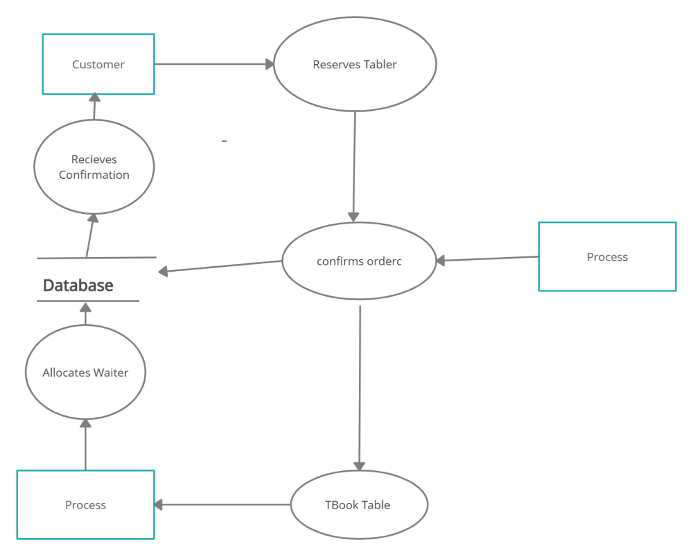

**7. E-R DIAGRAM FOR TABLE MANAGEMENT SYSTEM:**

The E-R Diagram defines 6 different entities and their attributes along with the relationship between these entities. The entities are Cashier, Customer, Chef, Taken by, Waiter, Restaurant . The relationship between these entities are as follows:

* Customer reserves Table
* Restaurant receives the order
* Confirms the table
* Waiter Manages the order
* Waiter serves the food
* Customer pays the bill

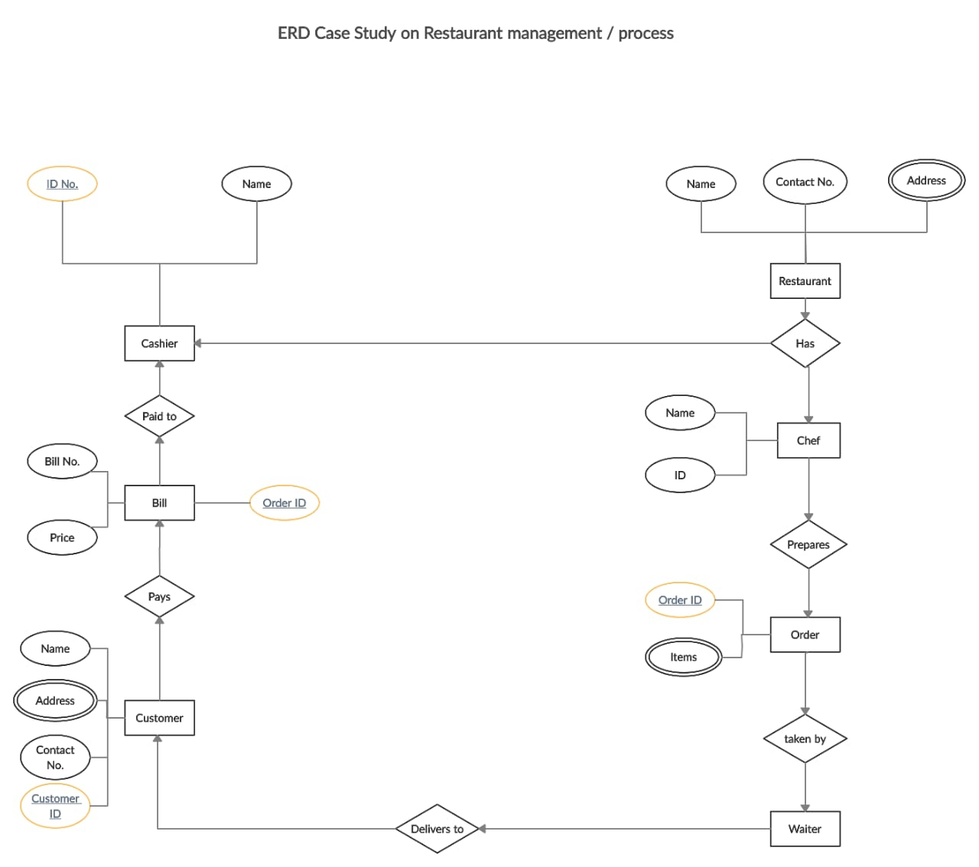**8. Sample Forms**

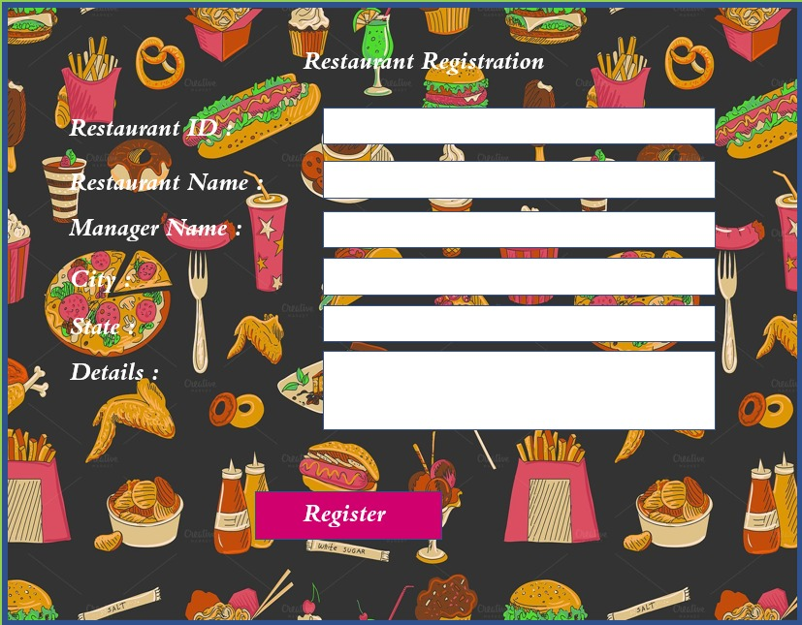

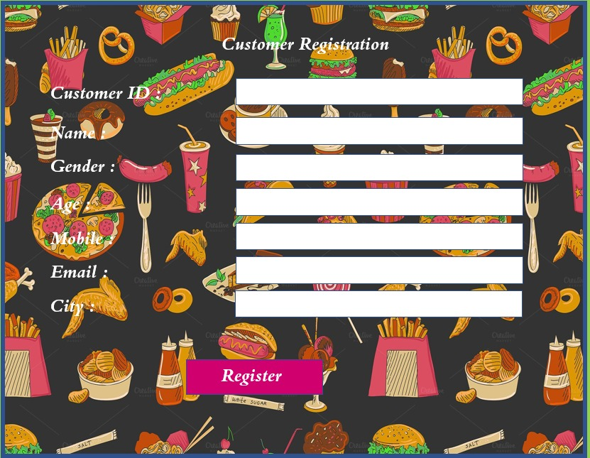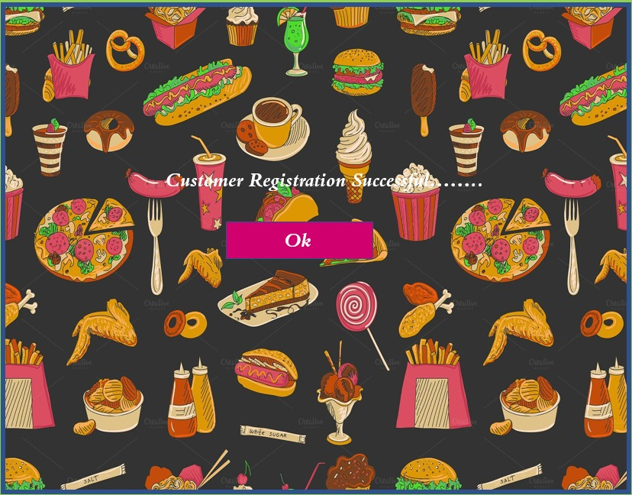

**Ex No: 11 EVENT MANAGEMENT SYSTEM**

Event management is the application of project management to the Creation and Development of large scale events such as festivals, Wedding ceremonies,formal parties. People that are need to find or book online event halls and or willing to see the packages and timing slots online about halls. They will able to get all this information through this system. To get success in the event management business, user should have strong network contacts of service provider. These contacts are essentially providers of specific services who can be mobilized quickly to participate in any given event. To make an event successful event Manager needs different service provider like Sound systems services, Lighting providers, Canteen services, stage construction and so on.

**Problems statement:**

* In any event many service providers work simultaneously and it is very hard to manage these providers.
* It is also important for event organizer that he has all the contacts details of these service Providers so that he can contact them any time to plan an event at given time.
* In present system Event Company has to do all management work manually.
* They keep all payment information on papers.
* There is no system to check the past expenses on any event.
* To do this they have to check payment register
* This task is very time consuming and tiresome.

so this system helps the event management company to manage their paper work online and they can also retrieve report of last event they have completed

**Dependencies/ External Systems**

Following are the tools / technologies, on which our system depends for its completion,

**Programming language**: PHP

**Front-End**: HTML, CSS, BOOTSTRAP(framework of CSS ANS JS)

**Hardware interface:** 512 MB RAM, WINDOWS 7/8

**Database:**MySql

XAMPP (Apache MySql PHP)

MySQL server is an open source relational database management system which is

used to store the database using SQL queries. In this project data of halls, wedding

lawns and data of accounts are stored in it.

**Tools:** Visual Studio

**Frame work**: MVC

MVC (Model View Controller) is used for implementing user interface on

computers.

**Product**: cyber cash

The CyberCash Secure Payment System is a complete system for conducting financial transactions on the Internet. It accepts both credit card payments and cash/coin transactions. The CyberCash system is a great solution for any Web site that wants to accept electronic payment for goods or services

**Requirements**

**Functional Requirement**

1. **Registration:**

* To enter into this site user has to register himself first.
* Requirements of registration are first name, last name, user
* name, email-id, password, confirm password etc.

2. **User Login:**

* The System provides facility to login into the system.
* Enter username and password
* User Profile page

3. **Select the Event:**

* The user can select the event and also select payment method.

4. **Forgot Password**

* The user can send reset link to the mail id to reset password.
* Input: Email id
* Output: Reset link send to Email id.

5. **Logout:**

* The system provides the facility to logout from the site
* Input : Select logout option
* Output : Logout from the system
* Processing : User will logout

6. **Online packages:**

* Online various payment packages will available to see.

7. **Time Slots:**

* Time slots for availability of a place or venue on which event going too held.

8. **Notification/updates:**

* User will get to know any notification, recent update or
* important massages through e-mail.

**Non-Functional Requirement**

**1. Performance Requirements:**

* The system need to be reliable
* If unable to process the request then appropriate error

message

* Web pages are loaded within few seconds

**2. Safety Requirements:**

* The details need to be maintained properly
* Users must be authenticated
* The database must be kept backed up

**3. Security Requirements:**

* After entering the password and user id the user
* can access his profile
* The details of user must be safe and secure
* Sharing of details

**Data Requirements:**

•Minimum 1GB needed to store our database.

•512MB RAM is also needed to install our whole system.

**External Requirements:**

How will our system connect to other software/components?

External requirements are following;

* To get important notification through E-mail, user must have to provide and

email address.

* For online payment; for example using cyber cash customer will provide

account number.

**DATA FLOW DIAGRAM**

**Data Flow Diagram level 0:**

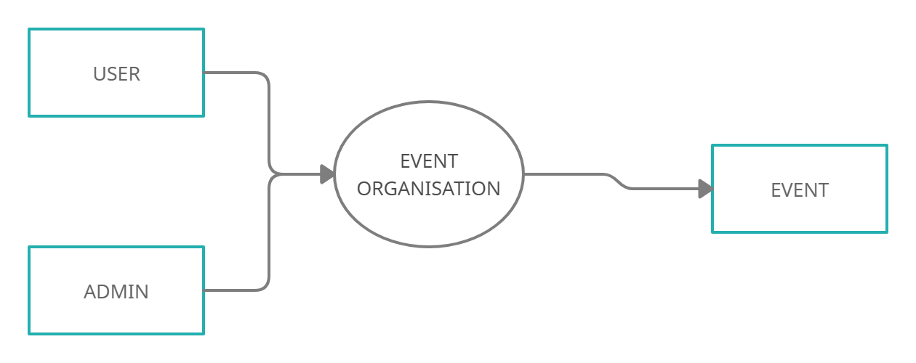

**Data Flow Diagram level 1:**

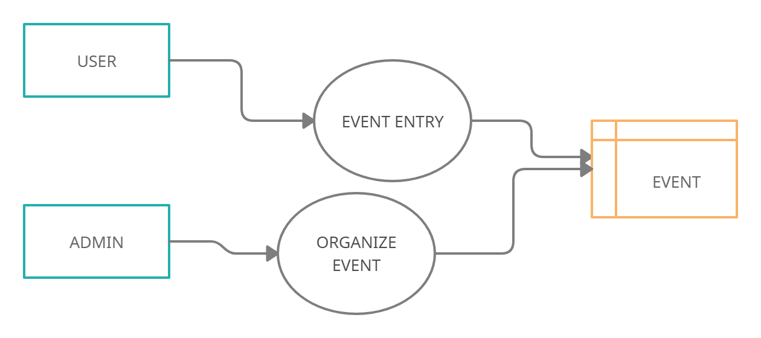

**Data Flow Diagram Level 2**



**Data Dictionary**

**1) User:**

|  |  |  |
| --- | --- | --- |
| ATTRIBUTES | DATA TYPE | CONSTRAINTS |
| U_id | Varchar(100) | PRIMARY KEY |
| U_Name | Varchar(100) | Not null |
| U_Contact | Varchar(100) | Not null |
| U_Location | Varchar(100) | Not null |
| U_Email | Varchar(100) | Not null |

**2) User Request:**

|  |  |  |
| --- | --- | --- |
| Name | Data Type | CONSTRAINTS |
| UR_Categories | Varchar(100) | NOT NULL |
| UR_Service | Varchar(100) | NOT NULL |
| UR_Location | Varchar(100) | NOT NULL |

**3) Account:**

|  |  |  |
| --- | --- | --- |
| Name | Data  Type | Constraints |
| AC_ID | Integer(4) | PRIMARY KEY |
| AC_Password | String(30) | NOT NULL |
| AC_Email | String(20) | NOT NULL |

**4) Admin:**

|  |  |  |
| --- | --- | --- |
| Name | Data  Type | Constraints |
| AD_ID | Integer(5) | PRIMARY KEY |
| AD_Name | String(30) | NOT NULL |
| AD_Password | String(25) | NOT NULL |

**SCREEN SHOTS:**

**Home:**

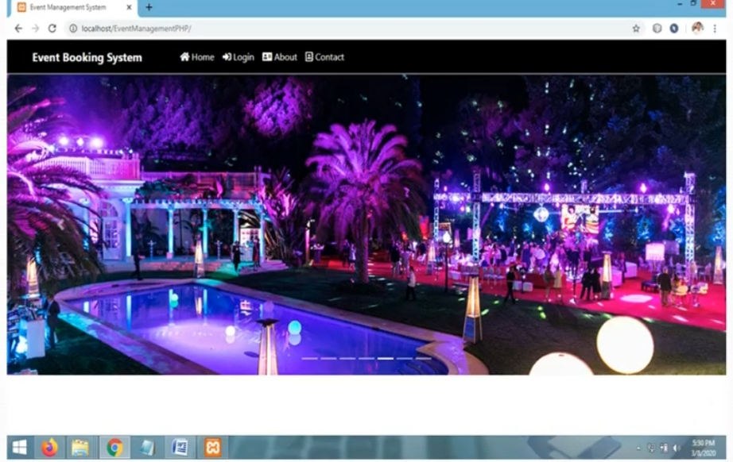

**User login**

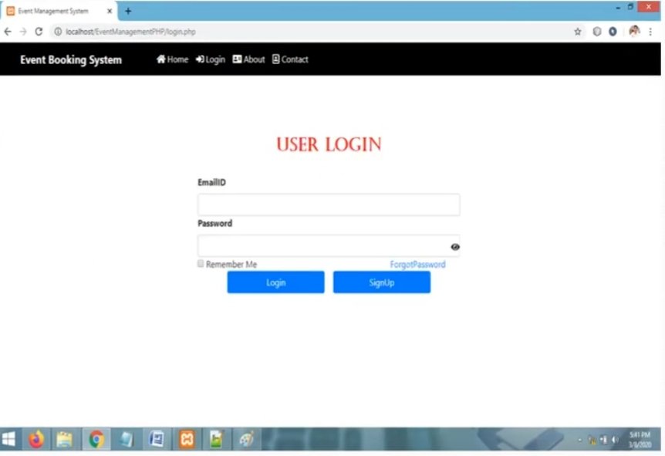

**Change password**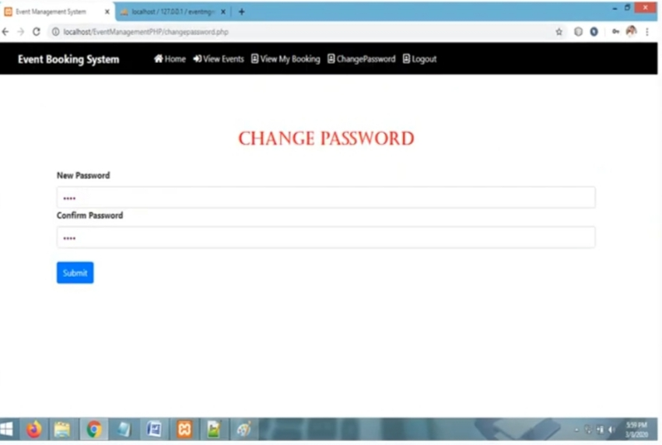

**Add sponsor:**

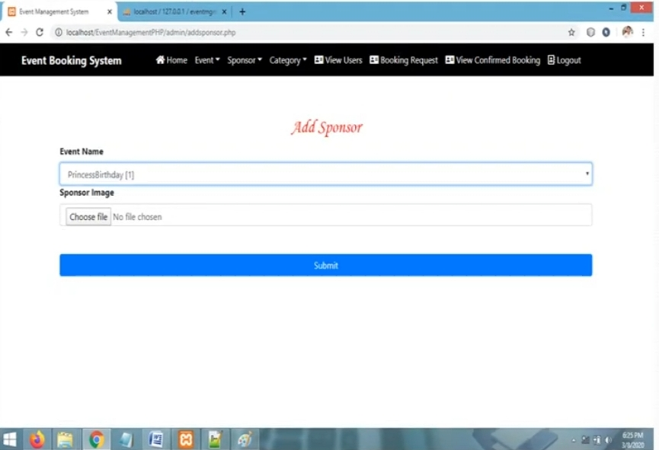

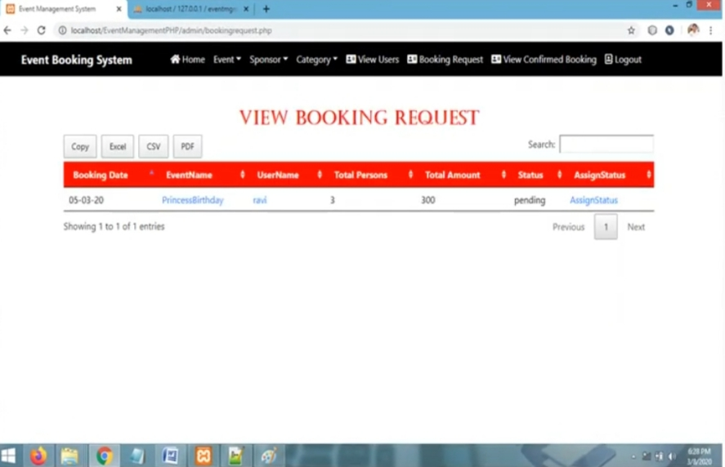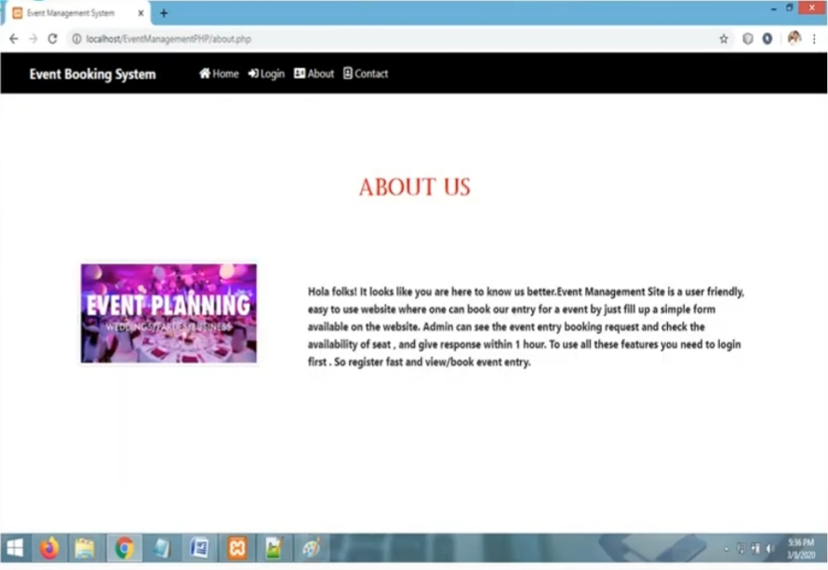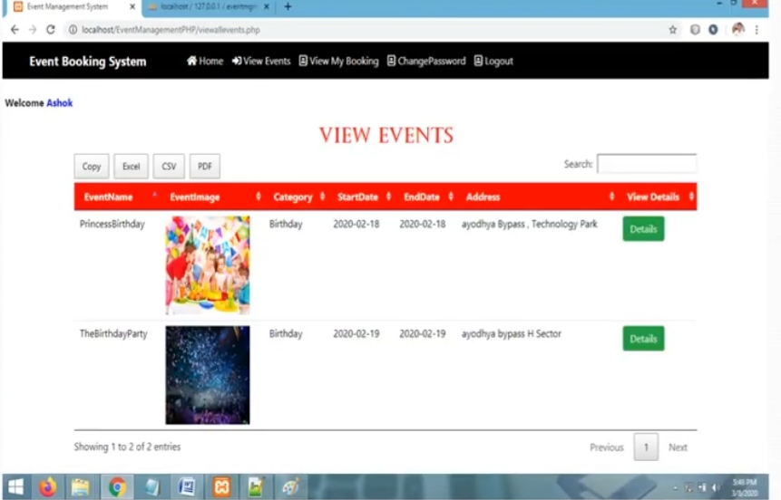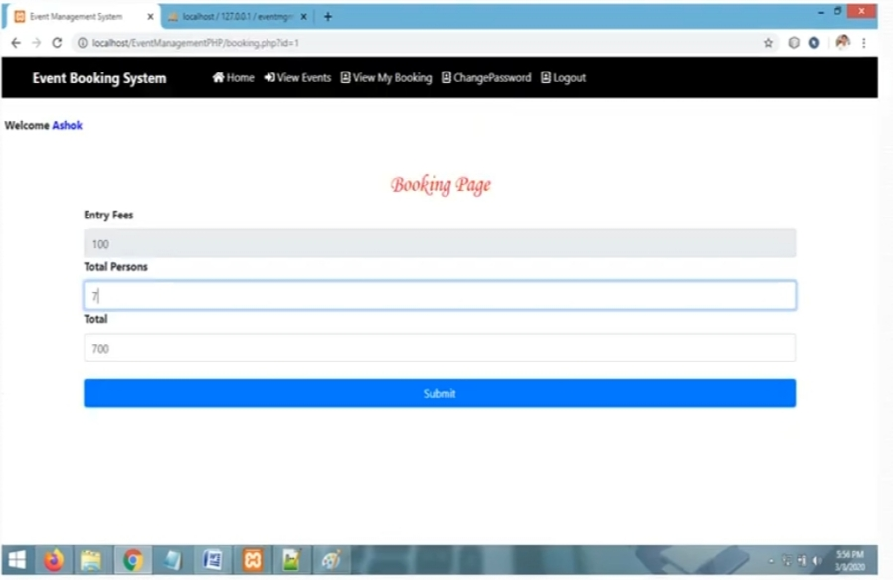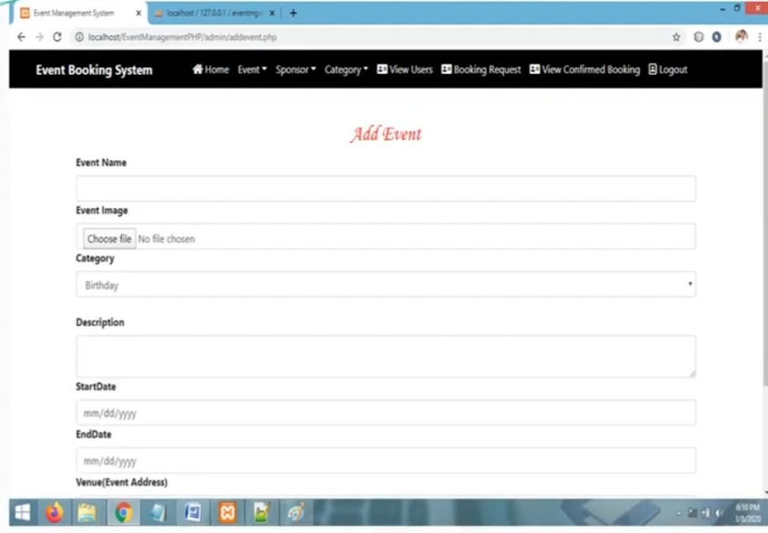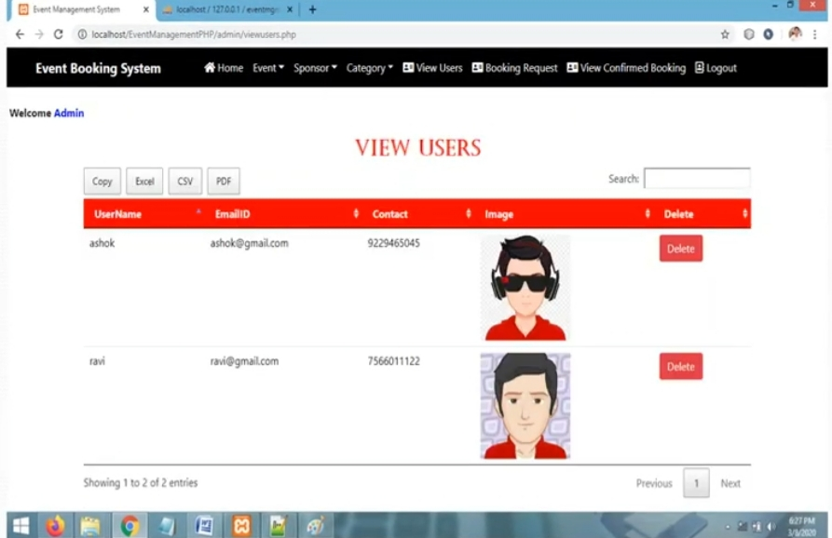

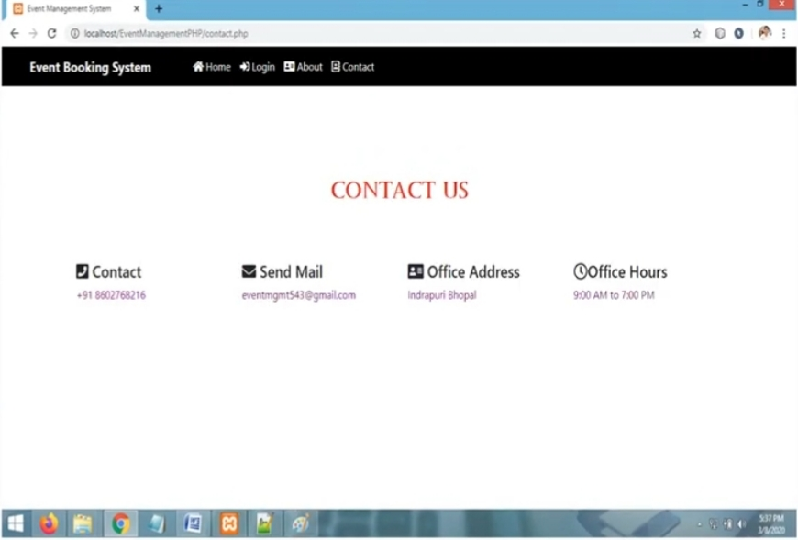

**Ex No: 12 CRIME REPORTING SYSTEM**

**1.ABSTRACT:**

* The aim of the project is to develop an online crime report and managing system which is easily accessible to the public.
* This System registers the complaints from people through online and it will also helpful to police department in catching criminals, in system and person can give any complaint at any time.

**2.PROBLEM STATEMENT:**

* This Application is used to develop a web based program using which people can report crime on online.
* There will be an ‘SOS ’capability in which, the user can press a button and his/her location will be sent to the nearest Police station.
* There will be a separate component for the accident victims so that FIR will be registered fast and treatment will be started as soon as possible.
* In the current system user information will be kept confidential and users complain will be forwarded to the nearest police station.
* It will search the address using IP address and then forwards the message to the police location from where the message has been received.
* We intend to create a project which will helps to bridge the gap between the police department and the common man.
* The main site will be maintained by the admin (from the police) who will then notify the user if the FIR has been registered and the necessary action has been taken.

**3. SYSTEM REQUIREMENT SPECIFICATION (SRS):**

**3.1Purpose:**

The main purpose of this application is to automate the complete operations of the Crime Reporting System. The intended audience is anyone working at a Crime Reporting System who wants to keep track and maintain the Crime records

**3.2Scope:**

The product is titled Crime Reporting System System(CRS)

The product will perform the following tasks:

* Allow users to register for Complaints.
* Allow admin to maintain the records of various different users and action taken by the police officers in a single system.
* Allows super admin to manage admins so that there is no abuse of power.

**3.3 Definitions, Acronyms and Abbreviations:**

* CRS – Crime Reporting System(CRS)

**3.4 Overview:**

* The SRS contains an analysis of the requirements necessary to help easy design.
* The overall description provides interface requirements for the Crime Reporting System, product perspective, hardware interfaces, software interfaces, communication interface, memory constraints, product functions, user characteristics and otherconstraints.
* Succeeding pages illustrate the functions of typical users accessing the system along with the different functions available for the admins and super admins and the responsibilities they must share to make proper and efficient use of the Crime Reporting System

**4.Hardware and Software Requirements**

**4.1 Hardware requirements:**

The database connectivity requires a hardware configuration that is on-line. This makes it necessary to have a fast database system running on high rpm hard disk permitting complete data redundancy and back-up systems to support the primary goal of reliability.

* Processor : Intel Core Duo 2.0 GHz or more
* RAM : 1 GB or More
* Hard disk : 80GB or more
* Monitor : 15” CRT, or LCD monitor
* Keyboard : Normal or Multimedia
* Mouse : Compatible mouse

**4.2Software Requirements:**

1. XAMPP (Cross Platform(X) for Apache, MySQL, PHP and Perl)
2. Notepad
3. Google Chrome or Mozilla Firefox or Internet Explorer

**4.3Languages Used:**

* Front End : PHP, HTML, CSS
* Back End : MySQL Database Server
* Operating System : Windows 7 or above

**5.FRONT-END &BACK-END DESCRIPTION**

**5.1FRONT-END DESCRIPTION:**

The proposed system (Crime Reporting System) is designed to help the Crime Reporting administrator to meet the sending and/or serving the request for complaints as and when required. The proposed system gives the procedural approach of how to bridge the gap between public, police officer, and the admin. The system has a registration process wherein the user can register to raise the complaints. The system will provide the admin the option to look at the details of the complaints and verify the integrity of the user before either accepting or rejecting the user. The administrator can also alter all the system data. The Super Admin feature has been added to manage and control all admins so that there is no abuse or corruption of power.

**5.2BACK-END DESCRIPTION:**

There are 9 tables. The 1st table contains User details such as username, password and so on.The 2nd table contains the details of users first information report(FIR) that are sent to the admin. The 3rd table contains the details of users about the missing person. The 4th table contains admins login details. The 5th table contains the admins response for the user report.The 6th table contains police officer login details. The 7th table contains the officer's response for the user report to the admine and the user.The 8th table contains police officer login details. The 9th table contains the officer's response for the user report to the admine and the user.

**6. DATA STRUCTURE:**

**6.1USER DETAILS:**

|  |  |  |
| --- | --- | --- |
| **Attributes** | **Data Type** | **Constraints** |
| Report ID | int(100) | PRIMARY KEY(AUTO INCREMENT) |
| User ID | varchar(100) | FOREIGN KEY |
| Phone Number | varchar(100) | NOT NULL |
| Email ID | varchar(100) | NOT NULL |
| Address | varchar(100) | NOT NULL |
| Aadhar card number | varchar(100) | NOT NULL |
| City | varchar(100) | NOT NULL |

**6.2 FRIST INFORMATION REPORT :**

|  |  |  |
| --- | --- | --- |
| **Attributes** | **Data Type** | **Constraints** |
| Report No | int(100) | PRIMARY KEY(AUTO INCREMENT) |
| Complaint ID | varchar(100) | FOREIGN KEY |
| Username | varchar(100) | NOT NULL |
| Report Details | varchar(100) | NOT NULL |
| Address | varchar(100) | NOT NULL |
| Date and time of the Incident | Datetime | NOT NULL |
| Picture/Vedio upload | varchar(100) | NOT NULL |
| Phone No | varchar(100) | NOT NULL |
| City | varchar(100) | NOT NULL |

**6.3 MISSING PERSON REPORT :**

|  |  |  |
| --- | --- | --- |
| **Attributes** | **Data Type** | **Constraints** |
| Report No | int(100) | PRIMARY KEY(AUTO INCREMENT) |
| Name | varchar(100) | NOT NULL |
| Complaint ID | varchar(100) | FOREIGN KEY |
| Age | varchar(100) | NOT NULL |
| Missing date | varchar(100) | NOT NULL |
| Contact no | varchar(100) | NOT NULL |
| Alter contact no | varchar(100) | NOT NULL |
| Picture/Video upload | varchar(100) | NOT NULL |
| City | varchar(100) | NOT NULL |

**6.4 Police Officer (login):**

|  |  |  |
| --- | --- | --- |
| **Attributes** | **Data Type** | **Constraints** |
| Username | varchar(100) | NOT NULL |
| Officer ID | varchar(100) | NOT NULL |
| Password | varchar(100) | NOT NULL |

**6.5 Police Officer Page:**

|  |  |  |
| --- | --- | --- |
| **Attributes** | **Data Type** | **Constraints** |
| Report No | int(100) | PRIMARY KEY(AUTO INCREMENT) |
| User Name | varchar(100) | NOT NULL |
| Action Taken | varchar(100) | NOT NULL |
| Status Upload | varchar(100) | NOT NULL |
| Contact No | varchar(100) | NOT NULL |
| Message | varchar(200) | NOT NULL |

**6.6 Admin (login):**

|  |  |  |
| --- | --- | --- |
| **Attributes** | **Data Type** | **Constraints** |
| Report No | int(100) | PRIMARY KEY(AUTO INCREMENT) |
| Email ID | varchar(100) | NOT NULL |
| Password | varchar(100) | NOT NULL |

**6.7 Admin Page:**

|  |  |  |
| --- | --- | --- |
| **Attributes** | **Data Type** | **Constraints** |
| Report No | int(100) | PRIMARY KEY(AUTO INCREMENT) |
| Police Officer ID | varchar(100) | FOREIGN KEY |
| Status of Report | varchar(100) | NOT NULL |
| Contact No | varchar(100) | NOT NULL |
| Message | varchar(200) | NOT NULL |

**6.8 Supreme Admine (details):**

|  |  |  |
| --- | --- | --- |
| **Attributes** | **Data Type** | **Constraints** |
| Name | varchar(100) | NOT NULL |
| Password | varchar(100) | NOT NULL |
| Officer ID | varchar(100) | NOT NULL |

**6.9 Supreme Admine (page):**

|  |  |  |
| --- | --- | --- |
| **Attributes** | **Data Type** | **Constraints** |
| Report No | int(100) | PRIMARY KEY(AUTO INCREMENT) |
| Admin ID | varchar(100) | NOT NULL |
| Status | varchar(100) | NOT NULL |
| Message | varchar(200) | NOT NULL |

**7.DATA FLOW DIAGRAM(DFD):**

**LEVEL 0 DFD:**

Supreme

admin

DATABASE

Police Officer

User/Public

ADMIN

**LEVEL 1 DFD:**

Admin

User

POLICE OFFICER

**LEVEL 2 DFD:**

Supreme Admin

Admin

### CITIZEN/USERS :

The Users has the permission to add complaint, crime report, missing person details, edit account, see complaint status send message and also change password.





### 2.Admin Features :

Admin has the permission to see users, block users, see user complaints, crimes & can reply.

He /She can add, delete, update and view the most wanted persons, missing persons, emergency complaint, complaints status, query, feedback and change password

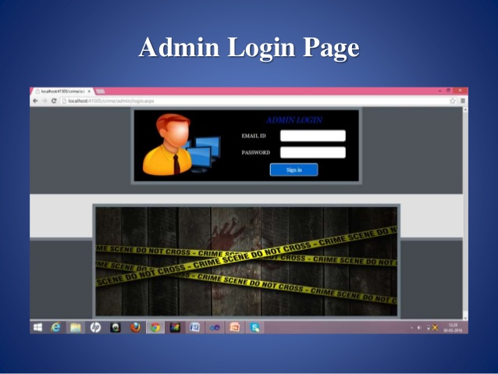

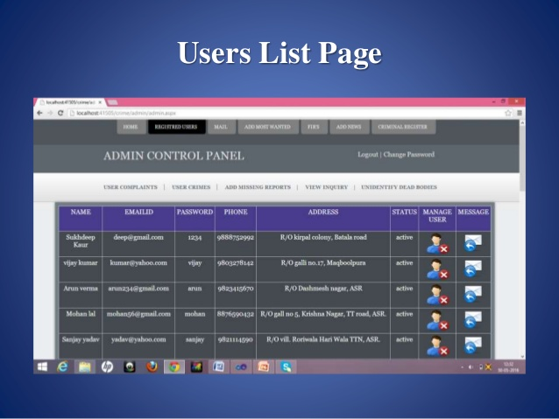

### 3.Police Officer:

By Login the police officer can view the complaints, update the complaint status and the emergency complaints. Also he/she can Inquire the complaint.

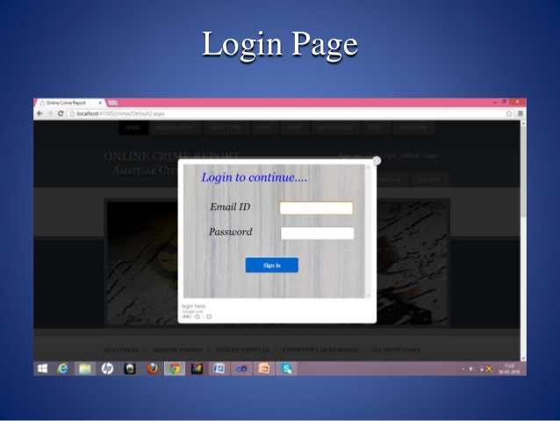

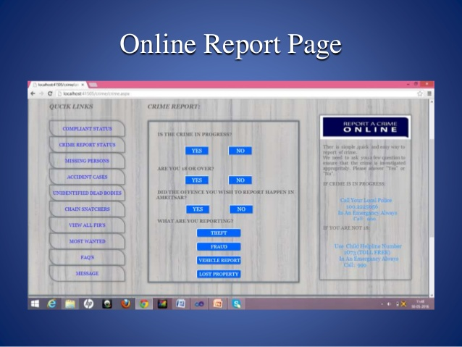

**CONCLUSION:**

The automated Reporting System is more functional because of people automatically can report crimes around them in picture or video format to the crime authority .

**RESULT:**

Thus the Crime Reporting System was implemented using the specified front end and back end tool.

**Ex No: 13 BOOK RESALE APPLICATION**

**PROBLEM DEFINITION**

There are many peoples who are interested in reading books. However, not many of them are regular in reading books because the new books are costly This project is aimed to developing an Online old used book information. This project Book management System explains about how Book Shops works with the computer application when any customers buy books from the store. Book management system is a project which aims in developing a computerized system to maintain all the books. Books can be searched by their Title, Description or Author and also books can be seen in appropriate categories. Each book is added with a unique Identification number and other details including a Shelf Number which helps to locate the book. We can also use Google Books to fetch details of a book from Internet. A cover image and PDF eBook can also be attached with the Book details. The Books can be issued and Submitted in a fast manner. The Library members can be managed more efficiently. We can easily get information like who took a particular book or which are the books taken by a specific Library members

**INTRODUTION**

In the world of software development there lots of improvement in the area ofArchitectural design and principles. The philosophies and implementation details arechanging as the people guiding the development of the application. In this fantasticand yet sometimes complex world of software development there are some tried andtrue architecture patterns and software development guidelines employed by mostarchitects. Also your design must have an ability to turn towards innovation instead oflending itself to common practices. Web services are one such area where architectsmust lean on their creative side and hope that their solutions are still successful. Inthis report we will explain an exciting voyage down the road of Web servicesapplication. From requirements to use cases, to database design, to componentframeworks, to user interfaces, we will cover each and every aspect of system designrequired to build an application with collaborative Web services. The reason why weselected online Bookstore web service is everybody walking down the street has someidea about bookstores. The objective of this project is to develop an e- book store

where books can be bought from the comfort of home through the Internet.An online book store is a virtual store on the Internet where customers can browse thecatalog and select books of interest. The selected books may be collected in ashopping cart. At checkout time, the items in the shopping cart will be presented as anorder. At that time, more information will be needed to complete the transaction.Usually, the customer will be asked to fill or select a billing address, a shippingaddress, a shipping option, and payment information such as credit card number. Ane- mail notification is sent to the customer as soon as the order is placed.

**SYSTEM REQUIREMENT**

Below are the tools, languages and software that were used to develop a Book Resale Application System:

**HARDWARE REQUIREMENTS**

System : Pentium IV 2.4 GHz.

Hard Disk : 40 GB.

Floppy Drive : 1.44 Mb.

Monitor : 15 VGA Colour.

Mouse : Logitech.

Ram : 512 Mb.

**SOFTWARE REQUIREMENTS**

Operating system : Windows XP.

Coding Language : JAVA

Data Base : MYSQL

IDE : Net Beans

**DATA FLOW DIAGRAM**

**LEVEL 1:**

OWNER

CUSTOMER

DATABASE

**LEVEL2**:

Upload Data

Login

OWNER

SEND MAIL

Logout

NHJKNH

**Level 3:**

USER

Registration

Login

Send Key to User

Add to cart

LOGOUT

View book

**Level 4:**

Admin

Customer

**TESTING**

**SYSTEM TESTING**

The purpose of testing is to discover errors. Testing is the process of trying to discover every conceivable fault or weakness in a work product. It provides a way to check the functionality of components, sub assemblies, assemblies and/or a finished product It is the process of exercising software with the intent of ensuring that the

Software system meets its requirements and user expectations and does not fail in an unacceptable manner. There are various types of test. Each test type addresses a specific testing requirement.

**Unit testing**

Unit testing involves the design of test cases that validate that the internal program logic is functioning properly, and that program inputs produce valid outputs. All decision branches and internal code flow should be validated. It is the testing of individual software units of the application .it is done after the completion of an individual unit before integration. This is a structural testing, that relies on knowledge of its construction and is invasive. Unit tests perform basic tests at component level and test a specific business process, application, and/or system configuration. Unit tests ensure that each unique path of a business process performs accurately to the documented specifications and contains clearly defined inputs and expected results.

**SCREENSHOTS**

**HOME**

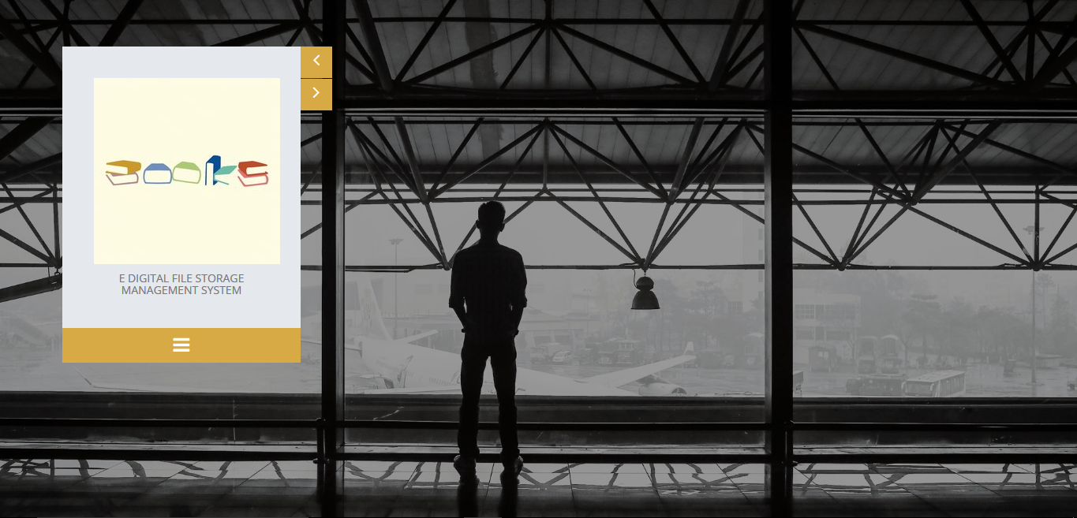

**ADMIN**





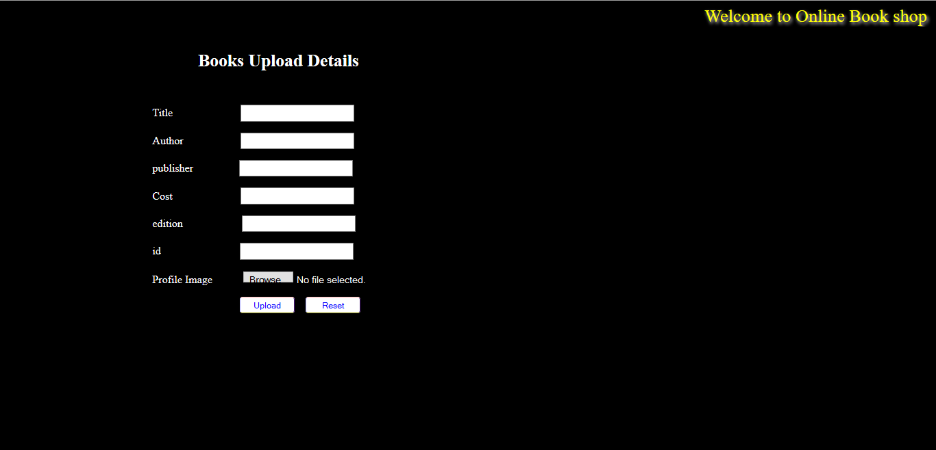

**USER**



**USER REGISTRATION**

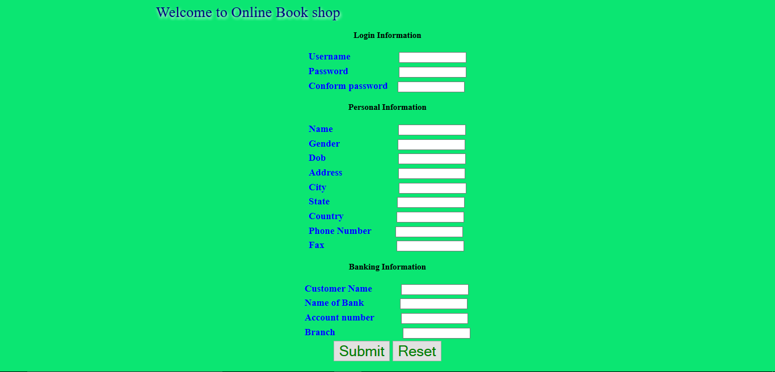





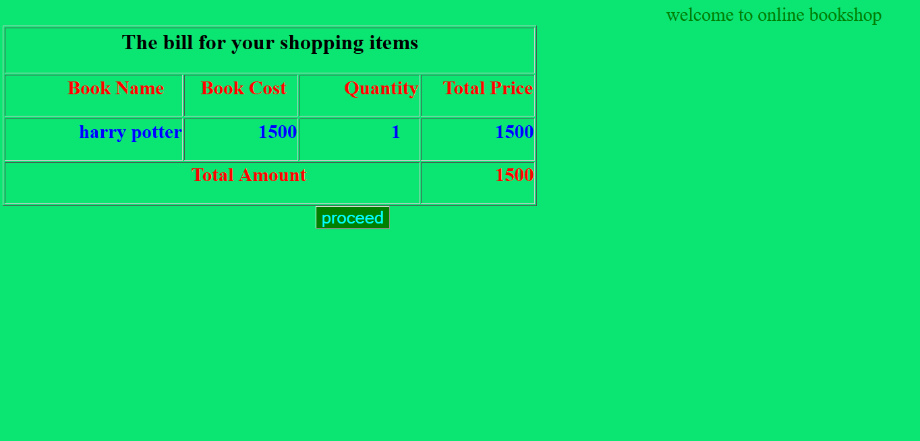

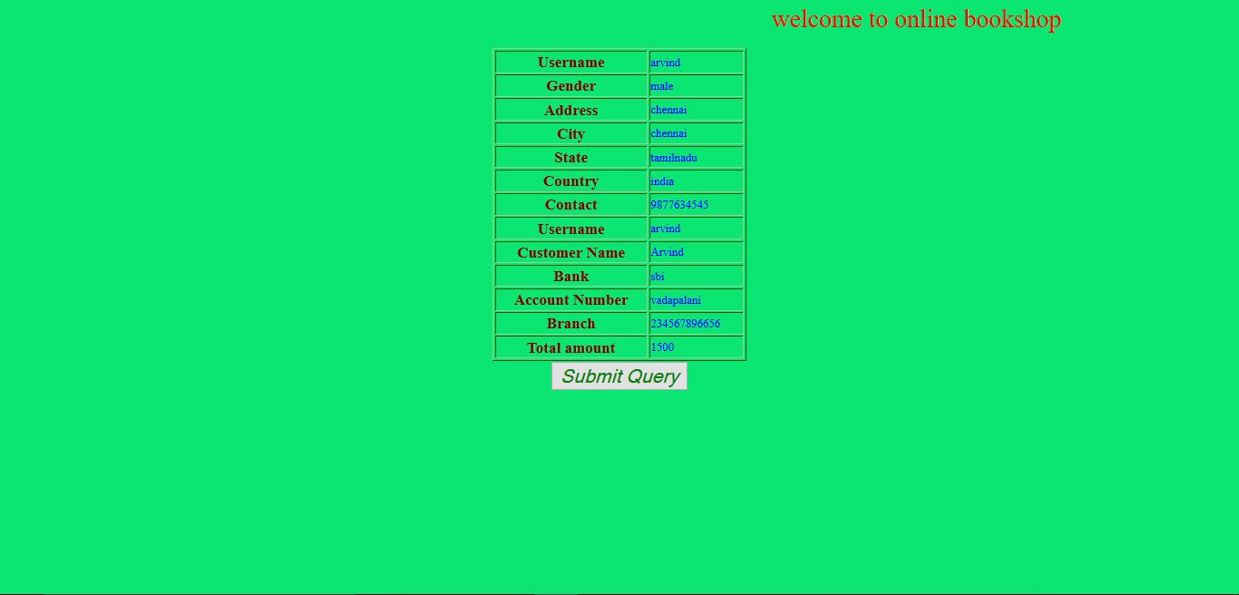



**RESULT**

Thus the Book Resale Application System was implemented using the specified front end and back end tools.

**Ex No: 14 TOURS AND TRAVELS MANAGEMENT SYSTEM**

**Abstract:**

**The Tours and Travel Management System is a webbased application. The main purpose of “Tours and travels management system” is to provide a convenient way for a customer to book hotels, flight, train and bus for tour purposes.**

* The main objective of this project is to develop a system that automates the processes and activities of a travel agency. In this project, we will make an easier task of searching places and for booking train, flight or bus.
* In the present system, a customer has to approach various agencies to find details of places and to book tickets. This often requires a lot of time and effort.
* We provide approach skills to critically examine how a tourist visits and its ability to operate in an appropriate way when dealing with the consequences of tourism, locally, regionally, and nationally including visitor security and ecological influences.
* It is tedious for a customer to plan a particular journey and have it executed properly.
* The project ‘Tours and Travels Management System’ is developed to replace the currently existing system, which helps in keeping records of the customer details of destination as well as payment received.

PROPOSED SYSTEM:

The proposed system is a web based application and maintains a centralized

repository of all related information. The system allows one to easily access the

relevant information and make necessary travel arrangements. Users can decide about

places they want to visit and make bookings online for travel and accommodation

**EXISTING SYSTEM:**

In the present system a customer has to approach various agencies to find detailsof places and to book tickets This often requires a lot of time and effort. A customermay not get the desired information from these office and often the customer may be misguided

**SCOPE OF PROJECT:-**

* The Website is developed based on real life. It is very helpful in business applications.
* Today's extremely exhausting work environment dictates that individuals requires
* some joyful holiday. The website will provides a stress-free joyful refreshing holidays
* with cost competitive and customized packages according to their requirements
* The Website is developed based on real life. It is very helpful in business applications.Today's extremely exhausting work environment dictates that individuals requiressome joyful holiday. The website will provides a stress-free joyful refreshing holidayswith cost competitive and customized packages according to their requirements

**HARDWARE REQUIREMNTS:-**

* RAM: 8GB
* SYSTEM TYPE: x64 based processor
* PROCESSOR: Intel Core 1.50Ghz

**SOFTWARE REQUIREMENTS:-**

* OPERATING SYSTEM: Windows10
* FRONT END: ASP.NET
* BACK END: MYSQL

INTRODUCTION

Tour

**INTRODUCTION:-**

* Tour & Travel is an irresistible word when it comes totour and travel packages. Weoffer tour and travel services including ticket bookings, hotel reservations,rentalcarservices, holiday tour packages, domestic tour packages.
* Whether you're looking for aweekend getaway to relax and indulge, a special holiday with friends and family, atrip to your favorite chill out spot or a new adventure, you've come to the right place.Tour&TravelTravel offers great deals and discounts on flights, railways, hotels,holiday packages, car rental and travel activities everything you need to plan, shop

**Modules of travel and tour management system:-**

**User Management:**  
  
a. Login.  
  
b. User profile.  
  
c. Update information.  
  
d. Role based rights.

**DATA FLOWDIAGRAM:-**

**LEVEL1:**

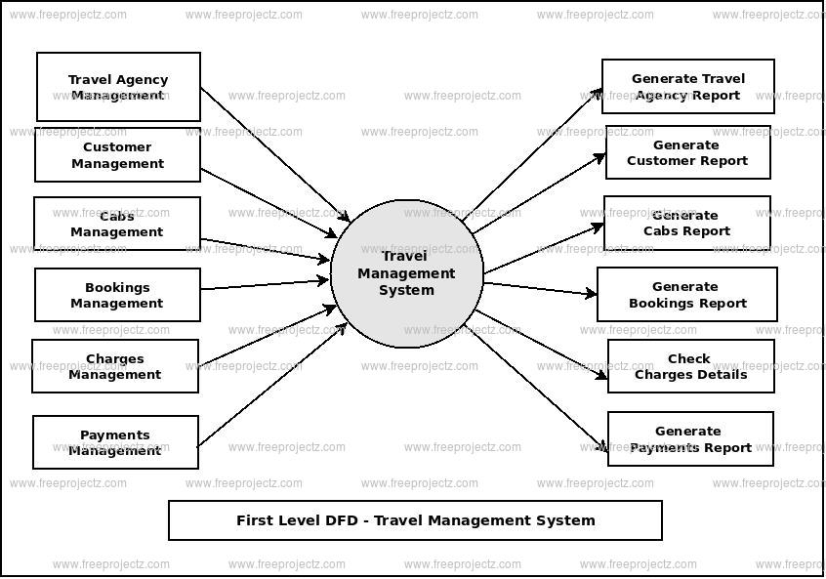

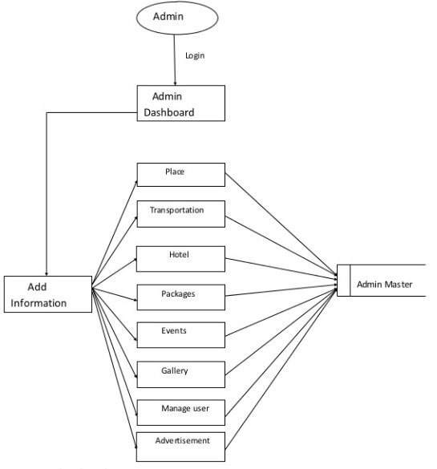

**LEVEL 2:**

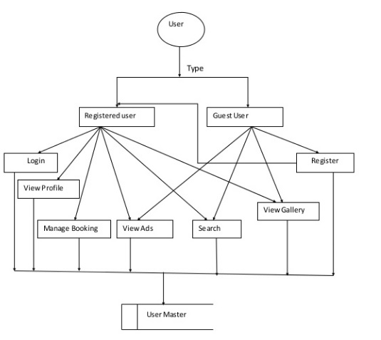

**DATABASETABLE:-**

|  |  |  |  |
| --- | --- | --- | --- |
| **Fieldname** | **Data type** | **Length** | **Key** |
| Username | Varchar | 20 | Primary key |
| Password | Varchar | 25 | - |
| Status | Varchar | 10 | - |

**User Registration:-**

|  |  |  |  |
| --- | --- | --- | --- |
| **Fieldname** | **Data type** | **Length** | **Key** |
| USERNAME | Varchar2(4000) | NO | -Primary |
| NAME | Varchar2(4000) | NO | **-** |
| ADDRESS | Varchar2(4000) | NO | **-** |

|  |  |  |  |
| --- | --- | --- | --- |
| PHONENO | Varchar2(66) | YES | - |
| PINCODE | Varchar2(66) | YES | - |
| EMAIL | Varchar2(4000) | YES | - |

**HOTELRESULT:**

|  |  |  |  |
| --- | --- | --- | --- |
| **Fieldname** | **Data Type** | **Length** | **Key** |
| IMAGE | BLOB | YES | - |
| HOTELNAME | Varchar2(4000) | YES | - |
| HOTELADDRESS | Varchar2(4000) | YES | - |
| HOTELTYPE | Varchar2(4000) | YES | - |
| HOTELPRICE | Varchar2(4000) | YES | - |
| FACI | Varchar2(4000) | YES | - |

TOURBOOK:

|  |  |  |  |
| --- | --- | --- | --- |
| **Fieldname** | **Data Type** | **Length** | **Key** |
| REQNO | Varchar2(40) | NO | - |
| NAME | Varchar2(40) | YES | - |
| ADDRESS | Varchar2(40) | YES | - |
| PHONENO | Varchar2(40) | YES | - |
| EMAILID | Varchar2(40) | YES | - |
| TOURNAME | Varchar2(40) | YES | - |
| CANTRY | Varchar2(40) | YES | - |
| TORIST | Varchar2(40) | YES | - |
| ARRIVEL | Varchar2(40) | YES | - |
| RETURN | Varchar2(40) | YES | - |
| HOTELNAME | Varchar2(40) | YES | - |
| ROOMS | Varchar2(40) | YES | - |
| ADULTSC | Varchar2(40) | YES | - |
| CHILDERN | Varchar2(40) | YES | - |
| DETAIL | Varchar2(40) | YES | - |
| TOUR-STATUS | Varchar2(4000) | YES | - |
| HOTEL-STATUS | Varchar2(4000) | YES | - |
| ROOMNO | Varchar2(4000) | YES | - |

**CARBOOKING:**

|  |  |  |  |
| --- | --- | --- | --- |
| **Fieldname** | **Data Type** | **Length** | **Key** |
| REQNO | Varchar2(40) | NO | -Primary |
| NAME | Varchar2(40) | YES | **-** |
| ADDRESS | Varchar2(40) | YES | **-** |
| PHONENO | Varchar2(40) | YES | **-** |
| EMAILID | Varchar2(40) | YES | **-** |
| VIHICLE | Varchar2(40) | YES | **-** |
| PICUP | Varchar2(40) | YES | **-** |
| CANTRY | Varchar2(40) | YES | **-** |
| PASSENGER | Varchar2(40) | YES | **-** |
| ARRIVAL | Varchar2(40) | YES | **-** |
| RETURN | Varchar2(40) | YES | **-** |
| CAR | Varchar2(40) | YES | **-** |

**ADMIN:-**

LOGIN-

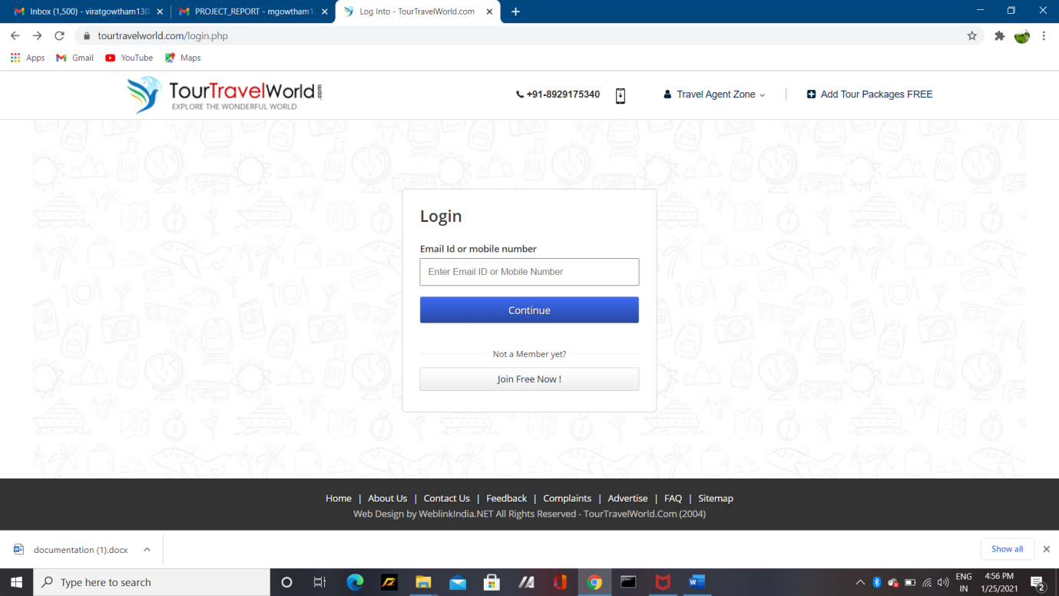



**PLACE LIST:-**

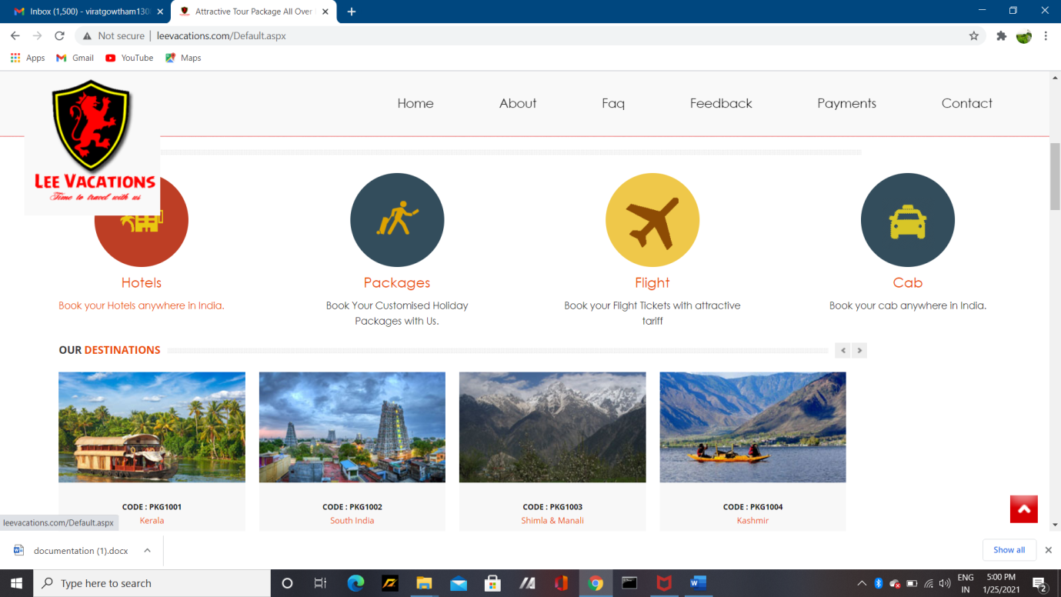

**CONCLUSION:-**

* The automated Tours and Travels Management System is more fuction because of people can get their package to the authority

**RESULT:-**

* Thus the Tours and Travels Management System was implemented using the specified front and back end tool

**Ex No: 15 APPLYING DATA MINING IN CYBER CRIME**

**PROBLEM DEFINITION**

* Our project is based on the reliability and availability of network services are being threatened by the growing number of Denial-of-Service (DoS) attacks.
* Effective mechanisms for DoS attack detection are demanded.
* Investigate and extract second-order statistics from the observed network traffic records.
* These second-order statistics extracted by the proposed analysis approach can provide important correlative information hiding among the features.
* By making use of this hidden information, the detection accuracy can be significantly enhanced.

**INTRODUCTION**

Cloud computing is a recent technology that aims at providing access to resources instantly as per the needs of the end users. Cloud enables its customers to make use of the resources that are widely distributed in the internet to perform computations without installing in their own PC’s and has to pay only for the service they consumed. All the computational requirements will be taken care of by the cloud service providers and hence all the complexities involved will be hidden from the user. NIST identifies the five key characteristics of cloud computing as on- demand self- service, resource pooling, broad network access, rapid elasticity and measured service.

Cloud offers services in three basic forms namely infrastructure (IaaS),platforms (PaaS) and Software (SaaS) and is on the stage of evolution to provide everything as a service (XaaS). As large magnitudes of data are moving onto the cloud, the attackers are keener to exploit the vulnerabilities associated with cloud and thereby to steal the sensitive data. Among the various threats tocloud computing, Denial of Service(DoS) attacks can prove to be the deadliest attack and even the Cloud Security Alliance has identified DoS attack as one of the nine major threats. In DoS attack, the intruder overloads the target system with service requests so that it cannot respond to any further requests and hence resources will be made unavailable to its users. Distributed Denial of Service(DDoS) attack makes use of several compromised machines called zombies to launch DoS attack on the target machine and the service is disrupted or delayed.DDoS attacks are getting more frequent these days and hence proper intrusion detection systems has to be deployed.

This project discusses the 2 various kinds of DDOS attacks possible and the various countermeasures that need to be followed to avert such attacks.

In computing,a denial-of-service attack (DoS attack) is a cyber-attack where the perpetrator seeks to make a machine or network resource unavailable to its intended users by temporarily or indefinitely disrupting services of a host connected to the Internet. Denial of service is typically accomplished by flooding the targeted machine or resource with superfluous requests in an attempt to overload systems and prevent some or all legitimate requests from being fulfilled.

In a distributed denial-of-service attack (DDoS attack), the incoming traffic flooding the victim originates from many different sources.

This effectively makes it impossible to stop the attack simply by blocking a single source. A DoS or DDoS attack is analogous to a group of people crowding the entry door or gate to a shop or business, and not letting legitimate parties enter into the shop or business, disrupting normal operations. Criminal perpetrators of DoS attacks often target sites or services hosted on high-profile web servers such as banks or credit card payment gateways. Revenge, blackmail and activism can motivate these attacks.

**SYSTEM REQUIREMENTS**

Below are the tools, languages and software that were used to develop a Book Resale Application System:

**HARDWARE REQUIREMENTS**

Processor : Intel Core 2

Speed : 1.1 GHz

Hard Disk : 250 GB.

Monitor : SVGA

Mouse : Optical

Ram : 1GB

Key Board : Standard Windows

Keyboard

**SOFTWARE REQUIREMENTS**

Operating System : Windows95/98/2000/XP/7.

Application Server : Tomcat6.0/7/8.X.

Front End : Java,HTML

&CSS

Scripts : JavaScript.

Server side Script : Java Server Pages.

IDE : Eclipse/ Net beans

Back End : MYSQL 5.0/ Heidi SQL 8.1

**DATA FLOW DIAGRAM**

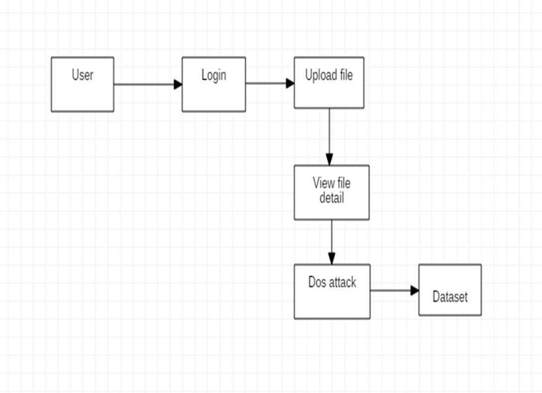

**TESTING**

**SYSTEM TESTING**

The purpose of testing is to discover errors. Testing is the process of trying to discover every conceivable fault or weakness in a work product. It provides a way to check the functionality of components, sub assemblies, assemblies and/or a finished product ,it is the process of exercising software with the intent of ensuring that the software system meets its requirements and user expectations and does not fail in an unacceptable manner. There are various types of test. Each test type addresses a specific testing requirement.

**UNIT TESTING**

Unit testing involves the design of test cases that validate that the internal program logic is functioning properly, and that program inputs produce valid outputs. All decision branches and internal code flow should be validated. It is the testing of individual software units of the application .It is done after the completion of an individual unit before integration. This is a structural testing, that relies on knowledge of its construction and is invasive. Unit tests perform basic tests at component level and test a specific business process, application, and/or system configuration. Unit tests ensure that each unique path of a business process performs accurately to the documented specifications and contains clearly defined inputs and expected results.

**SCREENSHOTS**

**HOME**

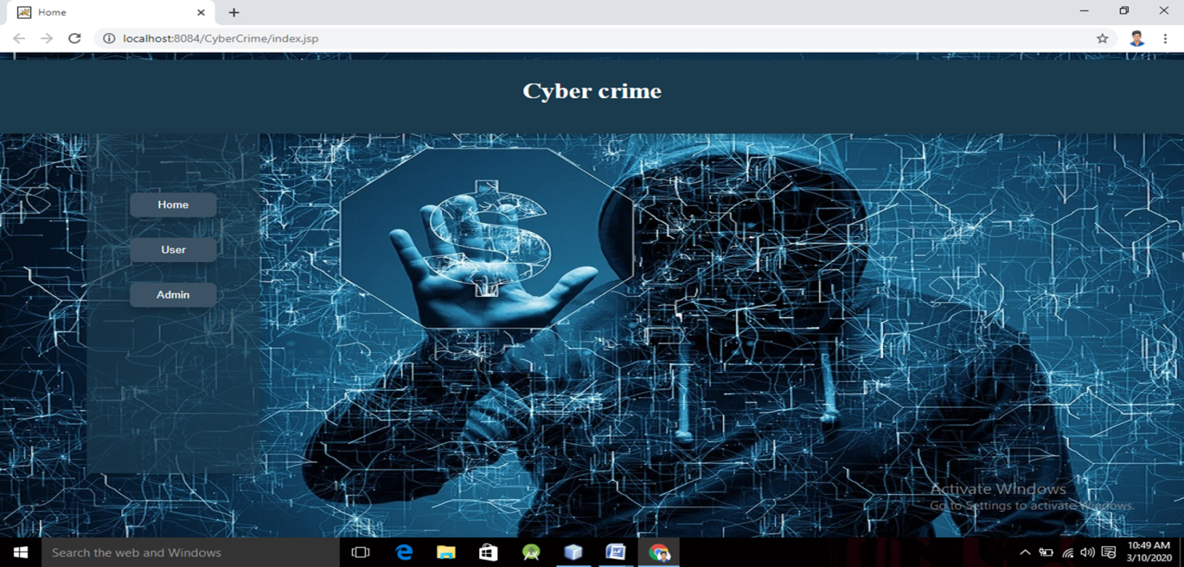

**ADMIN**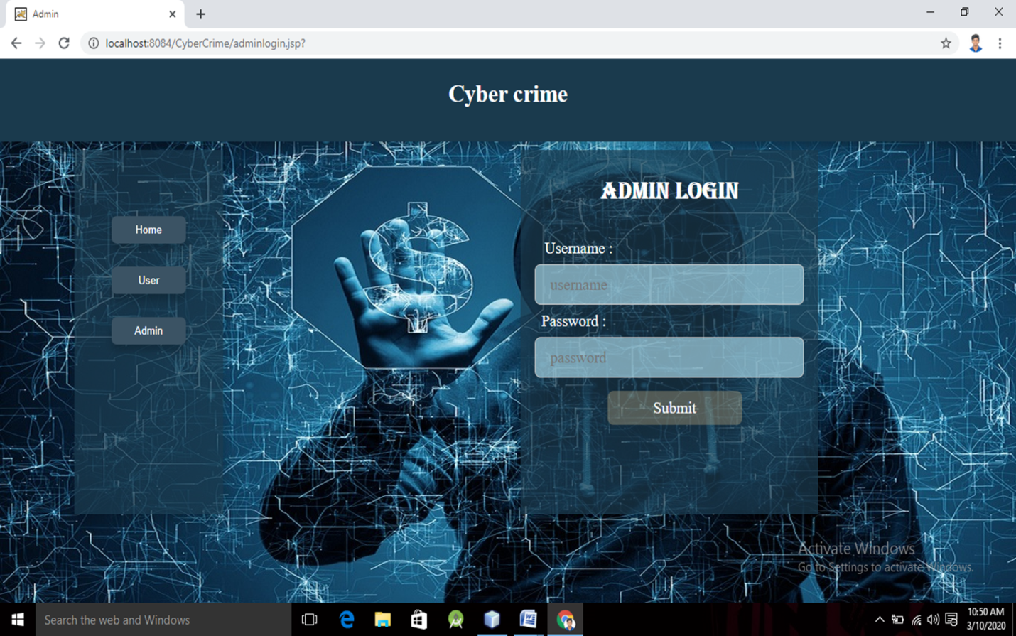

**USER**

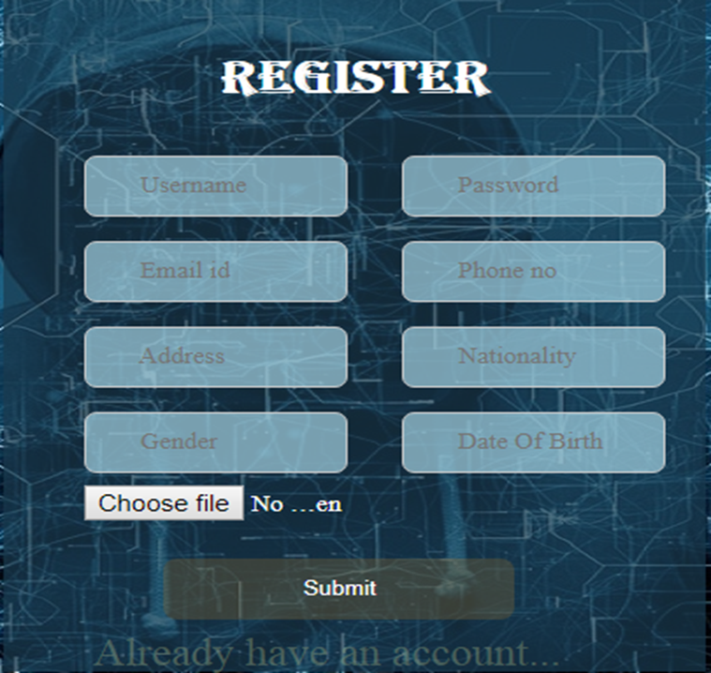

**USER REGISTRATION**

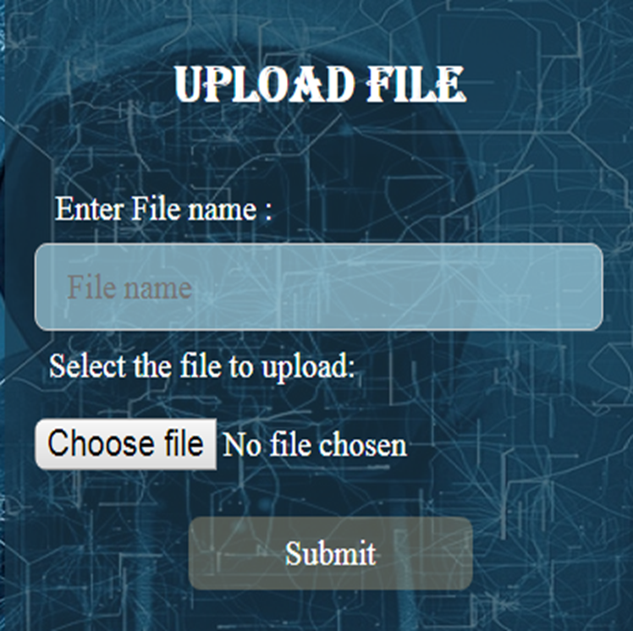

**RESULT**

Thus, the Book Resale Application System was implemented using the specified front end and back end tools.